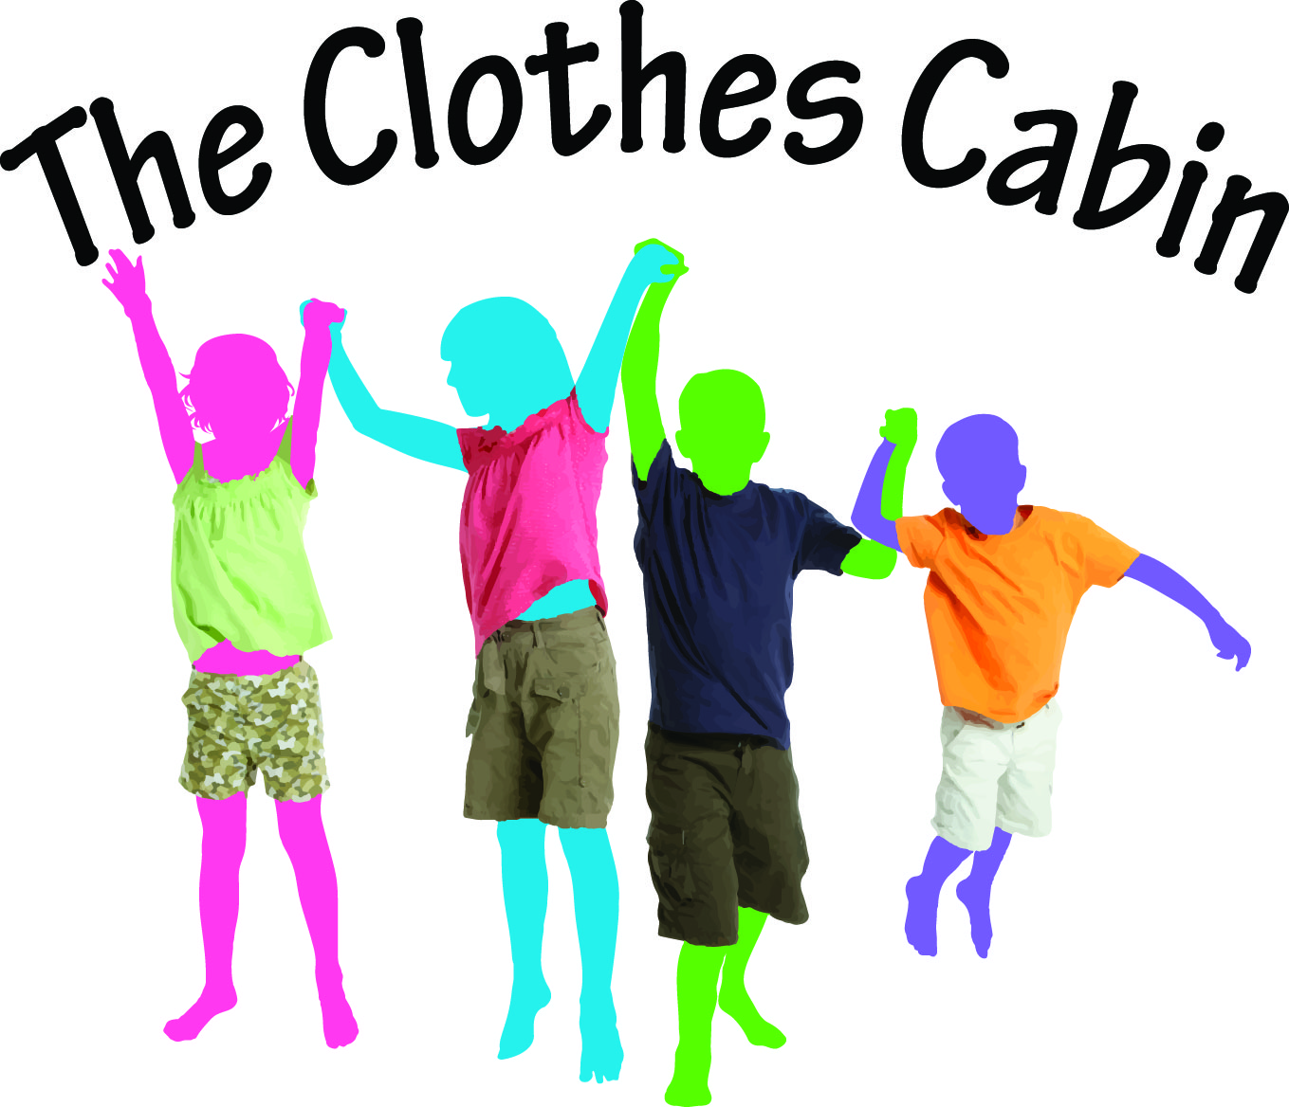

# Volunteer Opportunities at Clothes Cabin

The Clothes Cabin provides emergency clothing, shoes, and linens to the poor, homeless, and victims of domestic violence. Sixty percent of our clients are children. Our mission is that no person go without the clothing they need for employment, maintain a healthy and hygienic life, and be socially accepted.

Volunteers are the heart and soul of our organization. We value your time and your talents, and promise not to waste either. Please contact us to learn more about what we do, and how you can make a difference to others.

**Processing Clothes** - Donated clothes must be examined, sorted, steamed, hung, and stored. Volunteers who work in the processing area are responsible for insuring quality and presenting the clothes in an attractive way. You would also be restocking the racks and baskets in the shopping area.

Monday and Thursday 10am-2pm, Tuesday and Wednesday 9am-3pm, Thursday 6pm-8pm

**Client Services** - Our clients need help registering and selecting clothes. Volunteers use their computer skills to collect client data and service statistics; another volunteer acts as a store associate to help clients with clothes, bagging their selections, and retrieving linens upon request. Knowing Spanish is a big asset!

Tuesday and Wednesday 9 to 3:00, Thursday 6pm-8pm

**Boutique Sales** - Friends Resale Boutique uses volunteers to price, prepare, and display items for sale. In the boutique, volunteers help customers and ring the sales.

Monday and Thursday 10am-2pm, Tuesday and Wednesday 9am-3pm, Saturday 12pm-4pm

**Maintenance** - Volunteers handle light cleaning, and sometimes fix something or move fixtures.

Monday and Thursday 10am-2pm, Tuesday and Wednesday 9am-3pm