**Art Masterpiece: *Tree of Life*, 1909**

**by Gustav Klimt**

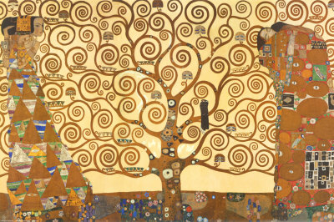

**Keywords:** Patterns, shape, color

**Activity**: Tree of Life drawing/painting

**Meet the Artist: Gustav Klimt** (1862- 1918) was an Austrian Symbolist painter and a member of the Vienna **Art Nouveau** movement.

* His major works include paintings, murals, sketches and other art objects. Klimt's primary subject was the female body. He also painted landscapes.
* Gustav Klimt was born in Austria, the second of seven children-- three boys and four girls. His father, Ernst Klimt, was a gold engraver, who was financially unsuccessful.
* Klimt lived in poverty for most of his childhood. Klimt was enrolled, at 14, in the Vienna School of Arts and Crafts in 1876, where he studied until 1883, and received training as an architectural decorator. His brother Ernst, who, like his father, was an engraver, also enrolled in the school. Klimt began a career painting interior murals in large public buildings. In 1897, Klimt was the leader of the Secession. This was a group of Austrian artists dedicated to artistic freedom and a style of art known as **art nouveau**. He began painting **landscapes and portraits** of wealthy Viennese ladies, receiving the support of loyal patrons. The radiant women in his portraits seem to appear in a kaleidoscope of **geometric shapes**, **spirals,** flowers, and **golden decorations**. Klimt also painted pictures of women that symbolized the cycles of life and death. His art celebrated love, beauty, and motherhood. Two of his most famous paintings are *Portrait of Adele Bloch-Bauer I* (1907) and *The Kiss* (1907-08;).
* Klimt died on February 6, 1918, in Vienna.

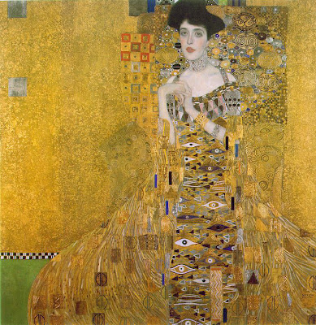

One final interesting fact about Klimt is that his Adele Bloch-Bauer I (shown above) sold in 2006 at auction for more money than any other painting ever had before: **$135 million!**

**The Artwork: Tree of Life:** Is a **symbol** used in many artworks and many religions . In most cases, The Tree of Life is used to signify **health and longevity.** Gustav Klimt painted with **brightness and boldness** and this is what he has shown in this painting . A large canvas is used to make this painting and detail is filled in every corner. To give a wonderful grand finish to this artwork, Klimt used **gold leaf paint**. There's a lot of symbolism behind the Tree of Life . The symbolism is really located in most cultures, all over the globe and is located in each and every aspect with the paintings. The **symbolism** shows the connection among three distinct worlds.

**Art Project Option 1:**

**Lesson: Students paint a tree using gold paint and add sequins**

**Materials:** black paper, gold paint, brushes, paper plates, sequins, glue and newspaper.

First, we talked about Gustav Klimt's "Tree of Life" painting and noted the **swirly branches**. I had kids duplicate the branches on their own paper using a paintbrush dipped in gold paint (NO PENCILS!) The paint dried fairly quickly, so they were able to glue the sequins on during that same class.

[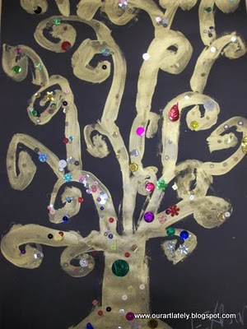](http://3.bp.blogspot.com/_xpN7oFFiqCk/TOQ40rX2wzI/AAAAAAAACPU/otaI69pvCtc/s1600/11-172-10%2B007.jpg)

**Art Project option 2:** **Drawing a “Tree of Life”**

**Materials:** white drawing paper, black sharpie markers, pencils, metallic paints in 2/3 colors, gold, silver or copper, paper plates for palettes, brushes, water cups for rinsing. Some newspaper for desks.

[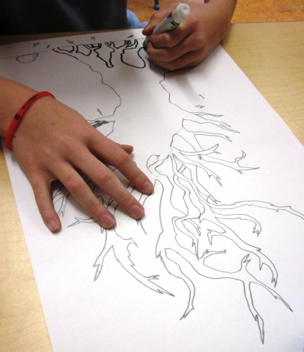](http://artlessonsforkids.files.wordpress.com/2011/02/img_1741.jpg)

Everyone should design their own interpretation and vision of the tree of life. The tree should fill up most of the paper space, the tree trunk could be any shape but relatively thick and there could be no visible leaves, just branches. This encouraged the students to be creative with the way they drew the branches and how they spread them out on the paper.

[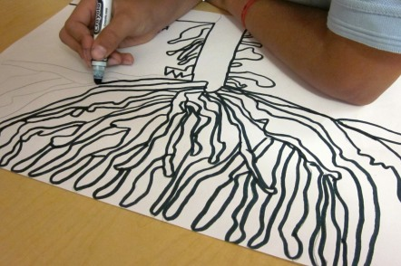](http://artlessonsforkids.files.wordpress.com/2011/02/img_1742.jpg)

The trees were outlined with black markers.

Next, the students divided sections in the tree trunk and filled each section with different lines and patterns with a dark pencil. These were not outlined with a black marker. Thick branches were also filled with pencil lines and patterns.

[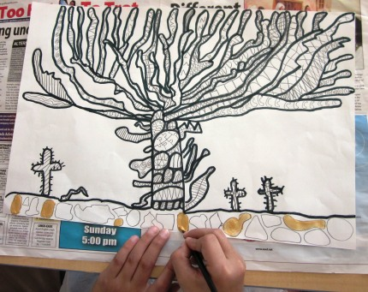](http://artlessonsforkids.files.wordpress.com/2011/02/img_1821.jpg)

Finally, **geometric** and **organic shape**s were designed under the tree, between the branches and open spaces around the tree. These were painted with the metallic paints and it certainly was a nice contrast with the black.[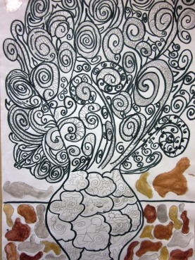](http://artlessonsforkids.files.wordpress.com/2011/02/img_2035.jpg)[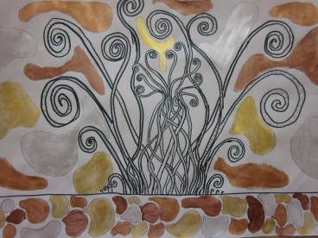](http://artlessonsforkids.files.wordpress.com/2011/02/img_2036.jpg)