1. When African colonies became independent countries, one of the first acts of many of the new governments was to
a. conduct a census.
b. build a new capital city.
c. change the names of places that had been named after colonial figures.
d. build new road systems.
e. establish trade ties with new dominant partners in an effort to break ties with the mother country.

2. The effects of increasing worldwide use of the Internet, popularity of Hollywood movies and consumption of other English-language media would BEST be described as examples of
- cultural globalization
- expansion diffusion
- the Anatolian diffusion
- vernacular regions
- contagious diffusion

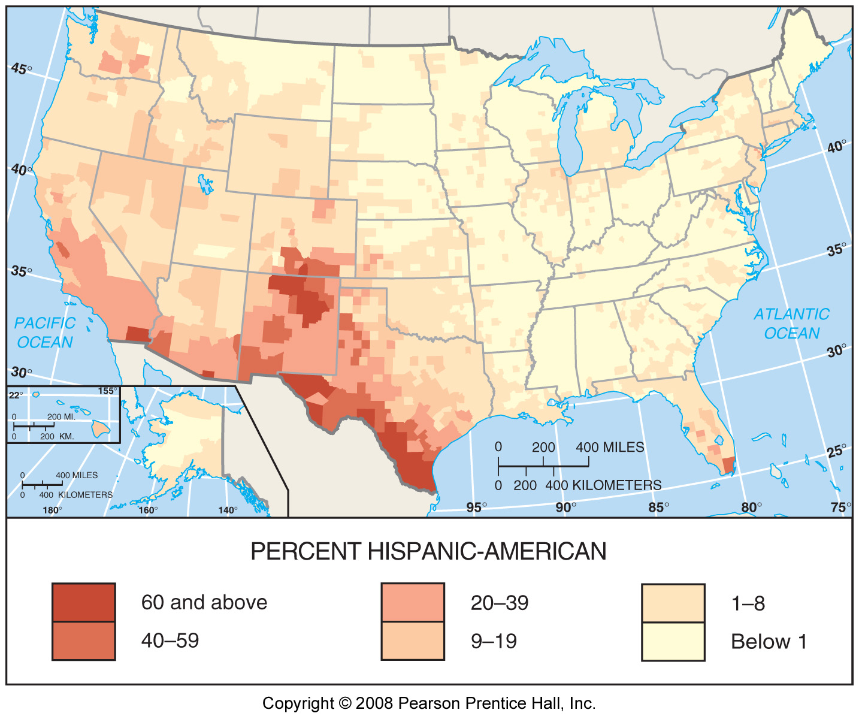
3. The map shown above shows clustering of ________________ in the United States
a) Native Americans
b) African Americans
c) Anglo Americans
d) Hispanic Americans
e) Asian Americans

4. The main effect of modern communications on social customs has been to
a. preserve folk customs, by increasing awareness of their uniqueness
b. stimulate the diffusion of folk customs around the world
c. increase the similarity of social customs in different locations
d. have little effect on the diffusion of social customs
e. emphasize the differences between places

5. Parts of South Africa and Zimbabwe have become demographically feminized due to
a) high rates of male AIDS deaths.
b) low number of male children born.
c) high female child birth rate.
d) migration of males to urban and mining jobs.
e) preferential female births.

6. Which of the following countries is NOT one of the largest Muslim populations outside the Middle East?
a. Indonesia
b. Pakistan
c. Bangladesh
d. Brazil
e. India

7. The forced expulsion, resettlement, and killing of cultural groups through the use of fear and violence, such as the conflicts within Rwanda and the former Yugoslavia in the 1990s is known as
- insurgency
- demilitarized zones
- polarization
- ethnic cleansing
- a product of strong government

8. Apartheid
a) is a legal system of racial separation
b) is still occurring in some parts of Eastern Asia
c) was a product of a majority ruling over a minority
d) became illegal in South Africa during the 1960s
e) is a system of undefined social restraints

9. The borders of American south or Dixie as a culture region are
- defined by the locations of NASCAR races and hegemony of country music radio stations
- poorly-defined fuzzy borders which overlap other American cultural regions
- a finite political boundary which surrounds the Civil War-era Confederate states
- defined by the planting range of agricultural products like peanuts and cotton
- a measurable transition zone of 10 miles along the Mason-Dixon line



10. The above images is most likely part of __________ cultural landscape.
- Jewish
- Muslim
- Buddhist
- Sikh
- Hindu

11. Which of the following toponyms are characteristic of Native American cultural landscape?
- Boston, Albany, Burlington
- San Juan, San Francisco, Los Angeles
- Coeur d'Alene, Des Moines, St. Jean-Baptiste
- Virginia, North Carolina, Charlotte
- Tallahassee, Mississippi, Walla Walla

12. Which is an example of a non-material aspect of culture?
a. church building
b. religious decoration
c. prayer
d. an altar
e. incense

13. Animism in Africa is declining rapidly as it gives way to what TWO other major world religions?
a. Islam and Christianity
b. Islam and Buddhism
c. Buddhism and Judaism
d. Judaism and Islam
e. Christianity and Buddhism

14. The identity of mestizos in Latin America is a mixture of cultural heritage from
- Asians and Africans
- Europeans and Africans
- Multiple tribes from what is today Arizona
- Native Americans and Europeans
- Africans and Spanish or Portuguese

15. Spain, Morocco, and Pakistan share commonalities in cultural landscape features such as architecture, vocabulary, and toponyms due to the influence of
- French language
- Islamic culture
- Roman conquest
- British imperialism
- Catholic missionaries

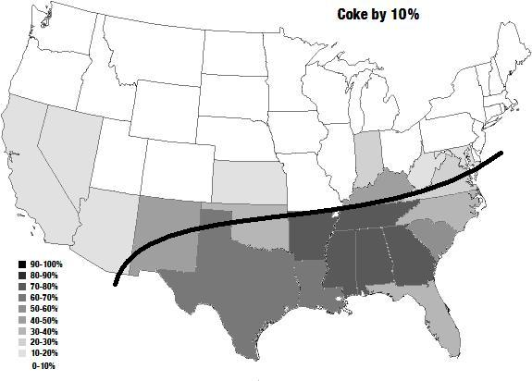

16. The choropleth map above illustrates the prevalence of the use of the word “coke” to refer to a soft drink. What term is most appropriately used to refer to the dark line?
a. isogloss
b. orthography
c. contour
d. branch boundary
e. dialect boundary

17. In cultural geography, the concept of ethnicity is best defined by
- differences based upon human physiological variations such as bone structure and hair texture
- differences based on factors that are linked to a person’s geographic origins or culture group
- differences based on linguistic variations like the Sino-Tibetan language family versus the Nilo Saharan language family
- differences based on human-environmental factors such as how climates and resource availability can affect the prosperity of a region’s population
- socially or politically contrived notions of identity based loosely on physical appearance

18. The majority of all Jews are found in what two countries?
a. Russia and the US
b. Israel and Saudi Arabia
c. Russia and Israel
d. Saudi Arabia and the US
e. the US and Israel

19. The notion that Columbus was the first European to discover America can best be characterized as
- a historical inaccuracy that has become folklore strongly tied to the national culture of the United States
- a historical fact that has been established by archaeological and archival evidence in Florida and Spain
- a myth that never actually occurred and has been removed from all textbooks in the Americas
- a turning point in the technology of navigation where longitude was accurately calculated at sea
- a historical fact that has been woven into the multicultural identity of the United States

20. The existence of Hindu Indian communities in places such as Guyana, Fiji and South Africa are the result of
- relocation diffusion of colonial- era labor migrations
- massive religious conversions
- the universal appeal of Hinduism and its diffusion across continents
- rural to urban migration
- hierarchical diffusion

21. The single language spoken by the greatest number of people in the world is
- Mandarin
- Hindi
- English
- Spanish
- French

22. Adherents to which religion are also likely to believe in other religions simultaneously and are therefore difficult to count precisely?
a. Buddhism
b. Christianity
c. Hinduism
d. Islam
e. Judaism

23. The effect of internet connectivity on global communication is
- an increase in the absolute distance between places
- decreases in the absolute distance between places
- increases in the friction of distance between places
- decreases in the relative distance between places
- decreases in the trigonometric distances between places

24. The naming of sports stadiums and other facilities for corporations (e.g. Petco Park, Chase Field, and Wrigley Stadium. is an example of
a. hubris.
b. memorial toponyms.
c. commodification.
d. post-modern toponyms.
e. Marxist backlash.

25. Jerusalem is considered a holy place by all of the following beliefs EXCEPT
- Catholicism
- Islam
- Animism
- Judaism
- Protestantism
26. The large number of individual languages documented in Africa has resulted primarily from
a. thousands of years of isolation among groups inhabiting the continent
b. repeated invasion by outsiders
c. introduction of many languages by the colonial powers
d. frequent migration by the different groups to other continents
e. a great deal of cultural interaction between various tribes

27. Government efforts to discourage native practice and languages in the United States and Canada were attempts to _____________ native groups.
a. segregate
b. protect
c. eradicate
d. assimilate
e. aggregate

28. ________________ culture is conceived as small, incorporating a homogeneous population, typically rural and cohesive in cultural traits.
a. Material
b. Popular
c. creative
d. changed
e. Folk

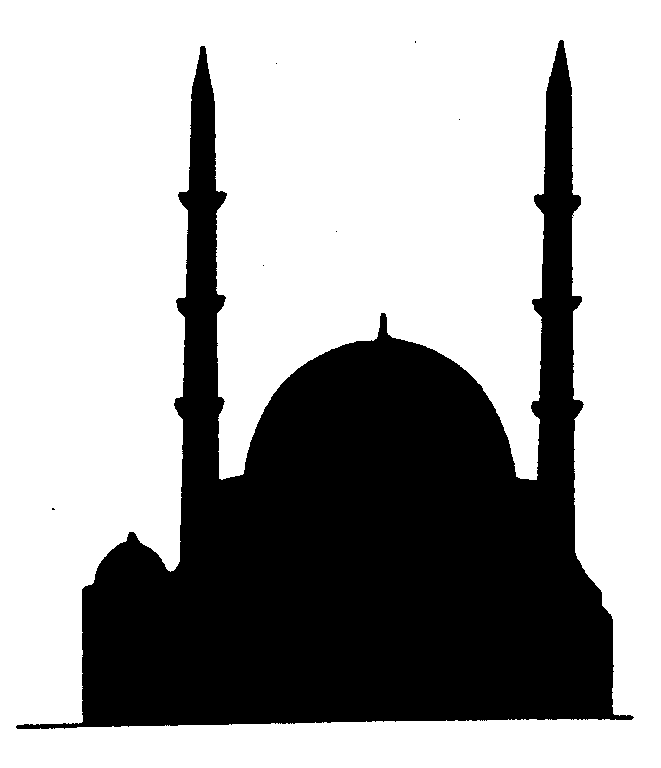
29. What religion is most likely indicated by the silhouette above?
a. Islam
b. Christianity
c. Buddhism
d. Hinduism
e. Judaism

30. Clusters of French toponyms in Louisiana, Dutch toponyms in Michigan and Welsh toponyms in Pennsylvania reflect
a. descriptive toponyms.
b. folk toponyms.
c. commemorative toponyms.
d. the land features as they relate to the place and the space.
e. names associated with migration.

31. Relocation diffusion is
A) the rapid and widespread diffusion of a characteristic throughout the population.
B) the spread of an underlying principle or idea.
C) the spread of an idea from persons of power to other persons.
D) the spread of an idea or trait through the physical movement of people from one place to another.
E) rarely occurs in the modern world.

32. Ethiopia is the cultural core of
  - Amharic/Coptic Christianity
  - Zen Buddhism
  - Sunni Muslims
  - Ba’hai Faith
  - Zoroastrianism

33. The most important language family in Sub-Saharan Africa is
- Khoisan
- Niger-Congo
- Nilo-Saharan
- Afro-Asiatic
e. Malayo-Polynesian

34. The conflict over religion in Ireland is intrafaith, between

a. Protestants and Catholics

b. Catholics and Orthodox Christians

c. Orthodox Christians and Protestants

d. Anglicans and Presbyterians

e. Anglicans and Episcopalians

35. The most widespread language family on earth is
- Sino-Tibetan
- Romance
- Germanic
- Indo-European
- Mandarin Chinese

36. Barbershops, Hooter’s, car garages, and Elk’s Lodges could all be considered
a) gendered spaces.
b) restricted areas.
c) social spaces.
d) sex zones.
e) off limits.

37. Popular customs/culture most frequently originate in
a. relatively developed countries
b. developing countries
c. less developed countries
d. agricultural areas
e. equally likely in all of the above regions

38. Which development helped with the rise of national languages beginning in the fourteenth century?
a. the creation of the American dictionary
b. agricultural revolution
c. Celtic migrations
d. fall of the Roman Empire
e. invention of the printing press

39. Hutterites differ from the Amish in that the Hutterites
a. reject modern technology.
b. accept modern technology for agricultural purposes.
c. are a rare form of Anabaptist.
d. live in Pennsylvania.
e. migrated from the Southern United States.

40. Which predominantly feminine economic activity is not counted in GNP calculations world wide?
a) commercial farming
b) tending a home garden
c) teaching
d) auto repair
e) textile mills

41. People in London, Melbourne, Vancouver, and Mumbai all speak

a. pidgin language

b. different lingua francas

c. different dialects

d. BRP languages

e. different creoles

42. Rural local cultures are often dependent on a single economic activity. Customs, beliefs, and artifacts are often intimately bound up with the economic activities. For example, the customs of the Plains Indians in early nineteenth-century North America focused on
a. corn agriculture.
b. cattle and sheep herding.
c. fishing.
d. bison hunting.
e. long distance trading.

43. Ethnic conflict in places like Nigeria, Sudan, and Congo are somewhat grounded in ethnicity, but the root of the problem can be seen as
a) lack of adequate education
b) a predisposition towards conflict
c) a conflict over resources and power
d) racial and ethnic animosity cultivated by mass media
e) global fears of African superiority

44. Both the Angles and the Normans contributed to the development of the English language because they
a. spoke Germanic languages
b. invaded England
c. spoke languages derived from Latin
d. diffused English around the world.
e. came from Germany originally

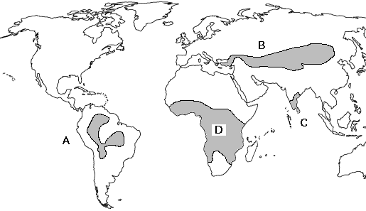

Three different language families are indicated on the map above by shaded areas. They are labeled A, B, C, and D. Match them in the list below.

45. Altaic

46. Dravidian

47. Amerindian
48. A universalizing religion
a. is based on the physical characteristics of a particular location on the earth’s surface
b. appeals to people living in a wide variety of locations
c. is rarely transmitted through missionaries
d. is usually found in less developed countries
e. all of the above

49. Features of the U.S. landscape, such as gas stations, tract home landscaping, chain supermarkets, and fast food eateries contribute to the phenomenon known as
a. placelessness
b. contextualization
c. cultural convergence
d. environmental determinism
e. possiblism

50. The sequent-occupance model examines a culture region and seeks to uncover the influence of
a. prior cultures
b. folk elements
c. popular elements
d. religion and politics
e. climate

51. The idea that an environment influences, but does not strictly determine, how a culture interacts with the environment is known as
A) environmental determinism.
B) environmental degradation.
C) cultural ecology.
D) cultural environmentalism.
E) environmental possibilism.

52. The area of origin of a culture is called
A) cultural environment.
B) cultural homeland.
C) culture hearth.
D) cultural landscape.
E) culture realm.

53. All of the following are examples of a functional or nodal region except
A) the area served by a Walmart.
B) the circulation of a daily newspaper.
C) the broadcast area of a radio station.
D) the area know as the “South”.
E) any market area for a retail business.

54. According to the Core-Domain-Sphere model
A) areas in the sphere part of the model impacted most by a culture.
B) influence of a culture decreases the further one travels from the core.
C) influence of a culture stays the same the further one travels from the core.
D) influence of a culture decreases as one travels in and around.
E) areas in the core have the least amount of cultural qualities

55. Which of these modern languages spread globally as a result of religious spread?
A) English.
B) Arabic.
C) French.
D) Spanish.
E) Chinese.

56. Which of the following is an example of hierarchical diffusion?
A) The spread of Spanish language to Latin America.
B) The spread of laptop computers from the upper class to the middle class.
C) The spread of AIDS from Africa to Europe.
D) The spread of Wal-Mart from Arkansas to the rest of the United States.
E) All of the above.

57. Islamic design and architecture often uses geometry and calligraphy because
- There have been a lack of talented Islamic portrait artists
- Regional folk culture preferences
- Quranic prohibitions on depicting the human form
- Islamic dominated regions are often severely short on art supplies
- In an ideal state, there should be no culturally dominated beauty ideal

58. In Turkey, the government uses the Swiss civil code, where as in Malaysia or Iran, ________ law is applied
- Jihadist
- Sharia
- Wahhabi
- Progressive
- Arabic

59. The Icelandic language has changed less than any other Germanic language. What is the best explanation for this?
- Iceland’s close contact with other people and activities
- migration by German tribes
- Iceland’s relative isolation from other places
- the extinction of the East Germanic group
- Iceland’s strong literary tradition

60. The language most widely used as a second language by hundreds of millions of people in India, Africa and elsewhere is
a. Spanish.
b. French.
c. Arabic.
d. English.
e. Portuguese.

61. In the US, the largest concentration of Amish are found in
a. Rhode Island, New York, and West Virginia
b. Tennessee, Arkansas, and Kentucky
c. Utah, Arizona, and Nevada
d. California, Oregon, and Washington
e. Pennsylvania, Ohio, and Indiana

62. Which of the following is true of popular culture?
a. it is practiced among a homogeneous group of people in the world
b. it is more static than folk culture
c. it incorporates traits that diffuse quickly to a wide variety of places
d. It spreads primarily through relocation diffusion
e. it promotes regional diversity

63. The world’s three major monotheistic religions originated in
  - East Asia
  - Southwest Asia
  - Eastern Europe
  - Western Europe
  - Africa
64. If three languages have similar words for colors and names of animals, but different names for a certain disease, what might be concluded about the time at which the disease first diffused?
a. the disease spread among a population that later divided and evolved into three different languages
b. The population divided and evolved into three different languages and then the disease spread
c. the disease spread to two different populations that later divided into two different languages
d. The disease and language spread to three different regions at the same time at the same rate
e. There can be no conclusions drawn about the initial diffusion of the disease based on language.

65. Which of the following regions has the greatest amount of linguistic and ethnic fragmentation?
a. Korea
b. Scandinavia
c. Colombia
d. India
e. Quebec

66. A country in which the majority of the population are Shiite Muslims
a. Iran
b. Egypt
c. Saudi Arabia
d. Serbia
e. Nepal

