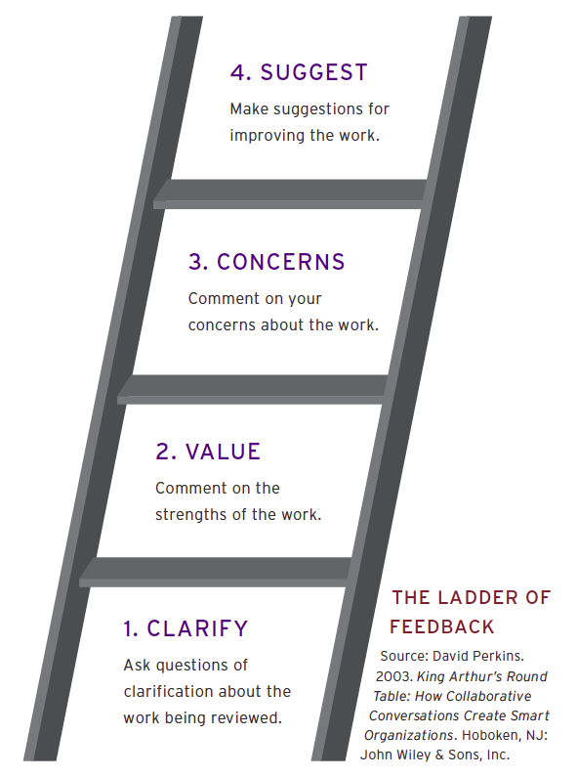

**4 – DEMOCRACY**

* **Responsible**
* **Taking Charge of Own Behavior**
* **Helpful and Caring**

**1 – ANARCHY**

* **Disrupting**
* **Unsafe**
* **Out of Control**

**2 – BOSSING**

* **Bothers others**
* **Teasing/Unkind**
* **Must be bossed to behave**
* **Disruptive**

**3 – COOPERATION**

* **Listens**
* **Follows Directions**
* **Participates**
* **On Task**