Love is . . . definition good example poor example quote
patient

kind

in not envious

does not boast

is not proud

not self-seeking

not easily angered

keeps no record of wrong

rejoices in the truth

does not like evil

always protects

always trusts

always perseveres

no fear (unafraid to show/express it)

sacrificial

committed

tolerates

humble

does life together

authentic/real/genuine

never fails!
Mini – Presentation

You and a partner will present on a sub-component of the definition of love to the class. In your presentation, you will include the following items:
- A definition of the sub-component
- An example of a good representation of the sub-component
- An example of a poor representation of the sub-component
- A billboard that communicates the idea of how it relates to leadership (8 ½ x 11 sheet of paper)

Examples of the billboard:

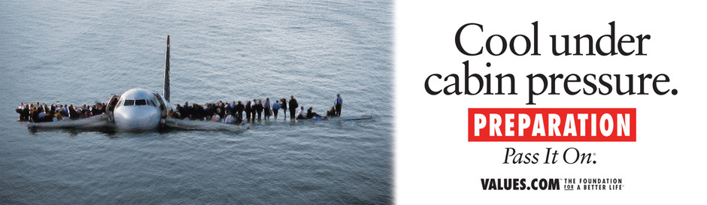



Rubric:
 | 1 pt | 2 pts | 3 pts | 4 pts
Ideas Content | Little evidence of thought-out ideas | Ideas are incomplete | Ideas are very well thought-out and complete | Ideas are very well thought-out and complete
Leadership | Pres. contains little connection to leadership | Pres. attempts to make connection to leadership | Pres. makes connection to leadership | Pres. clearly makes connection to leadership
Creativity | Not creative | Somewhat creative and somewhat entertaining | Creative and entertaining | Very creative and entertaining
Design/organization | Design takes away from the pres. | Design somewhat enhances pres. | Design enhances pres. | Design greatly enhances pres.

Total: _______ / 16 pts

Love Metaphor Project

You will create a collage that represents the 20 components of Love that we have discussed in class. For each component, you will find a picture/graphic that represents it. Use the following organizer to brainstorm ideas. The final draft will be due: _________________________

Component picture of . . .

