Culinary I

In Culinary I you will:
- Learn kitchen tools and equipment
- Bake cakes, cookies, pies, and more
- Identify and perform knife cuts
- Study nutrition and career opportunities
- Work on Employability Skills



Culinary 2

In Culinary 2 you will:
- Participate in catering events
- Have opportunities to compete
- Join FCCLA
- Master baking and knife skills
- Create Menu’s and Compete in Chopped Challenges
- Honors Cord Opportunities



Culinary 3:
• Create your own food truck
• Attend food shows & field trips
• Create menus & cater events
• Compete for scholarships
• Participate in hospitality workshops
● Opportunity to qualify for an honors cord

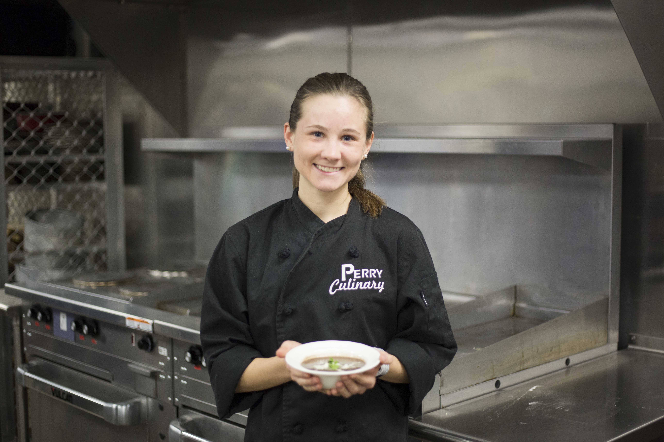
Dual Enrollment Available!

Interested in getting college credit while in high school?
Select classes are available through Scottsdale Community College. For more information, check out http://www.scottsdalecc.edu/future_students/high-school/dual-enrollment

Notice of Nondiscrimination
Chandler Unified School District does not discriminate on the basis of race, color, ethnicity, national origin, religion, sex or gender, sexual orientation, disability or age in its programs and activities and provides equal access to the Boy Scouts and other designated youth groups. The following persons have been designated to handle inquiries regarding the nondiscrimination policies:

Aviso de no discriminación
Distrito Escolar Unificado de Chandler no discriminan en base de raza, color, etnia, origen nacional, religión, sexo o género, orientación sexual, discapacidad o edad en sus programas y actividades, proporcionan acceso en condiciones de igualdad a los Boy Scouts y otros grupos de jóvenes. Las siguientes personas han sido designadas para tratar preguntas en cuanto a las políticas de no discriminación:

Compliance officer for Title IX
Dr. Craig Gilbert, Assistant Superintendent- Asistente de Superintendente
Sandy Cooper, Assistant Superintendent- Asistente de Superintendente
1525 W. Frye Rd.
Chandler, AZ 85224
(480) 812-7624

Compliance officer for Section 504- Funcionario de Cumplimiento para Sección 504
Dr. Kymberly Marshall, Director of Student Services
500 W. Galveston St.
Chandler, AZ 85225
(480) 224-3732
Love Cooking
& Baking?
Then check out Perry’s
Culinary Arts Program . . .


Angela Stutz, & Arline Pryor
Culinary Arts Instructors

