Students Logging Into Think Central
URL: www.cusd80.com
Click on Online Grades in the top right hand corner of the page.
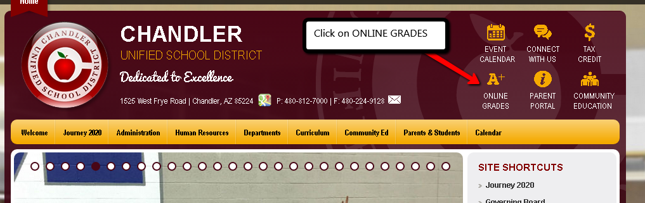
Login to the student portal using your computer username and password. (Hint: S + Student#)
You will click on CUSD Student Links on the left hand side menu closer to the bottom of the screen.
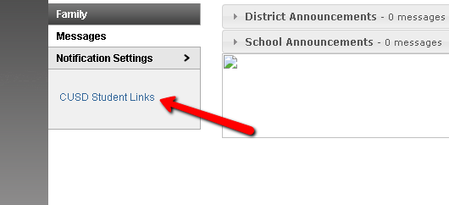
A new tab or window will open up with the available student links. Click on the Think Central application.
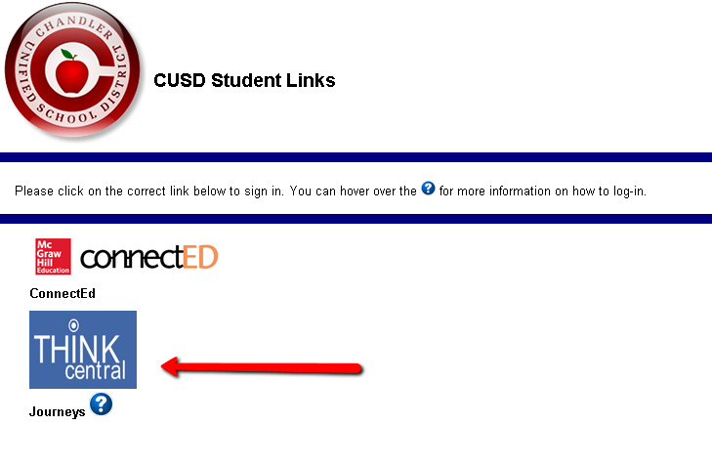

It will prompt you to login.
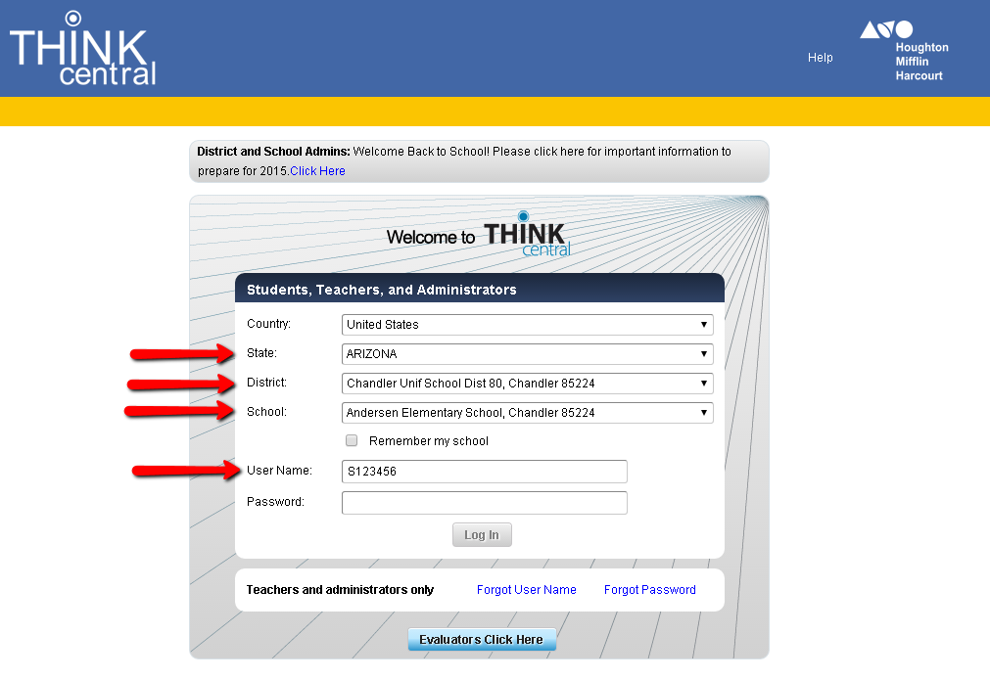
Select ARIZONA
Select Chandler Unif School Dist 80, Chandler 85224
Select your school
Type in your username: S + Student ID (ex. S123456@cusd)
Type in your password: s + Student ID + ! (ex. s123456!)

