Easiteach Upgrade
How to use the DayDream Education Wall Charts

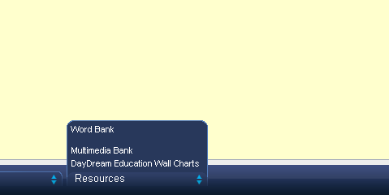

Click on RESOURCES at the bottom of the screen

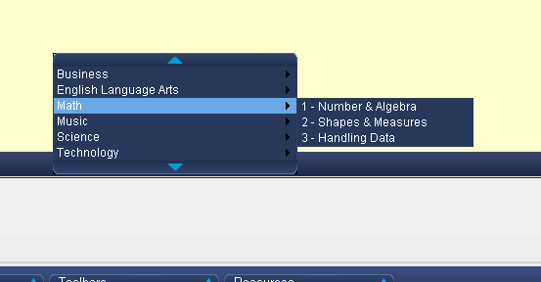

Click on your subject and subcategory…
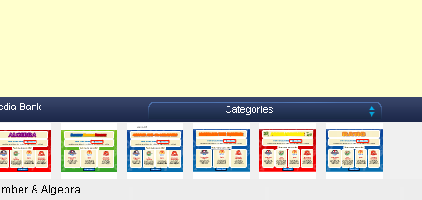

Click on the wall chart you want to use, drag it out to the screen and resize to fit the whole screen. Click on the hand to get your “use tool” and have fun!

