­­

FITNESS UNO

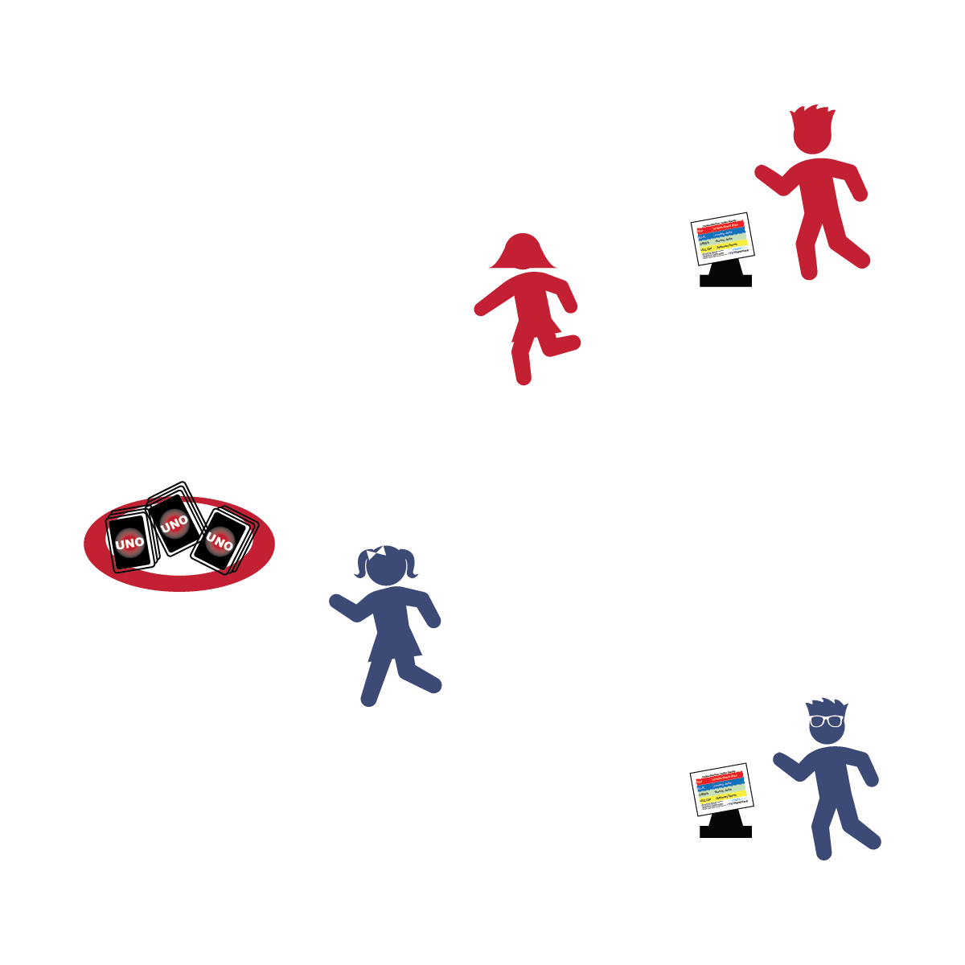

* **Color Your Plate:** Different colored fruit and veggies have different health benefits. Be sure to have a colorful plate of fruits and vegetables at every meal. Eat a rainbow of fruits and veggies!
* I will follow the rules and have fun with my friends and family.

**Activity Procedures:**

1. Today’s friendly competition is Fitness Uno. We will be developing our personal fitness with friends and family. This game is played in 2 phases.
2. During Phase 1, your team will run in relay-race format (1 player at a time) to the hoop to grab 1 UNO card per visit. Do not look at the card when you pick it up. When you return, give your teammate a high-5, and then she/he will run to the hoop. Place the cards face-down in a pile.
3. When your team has 10 cards, it’s time for Phase 2. During this phase, your team will work to return all of your cards to the hoop. To do that, flip over 1 UNO card at a time and use the UNO Fitness Chart to determine which exercise to perform. The number on the card determines the number of exercise repetitions you’ll complete. Everyone on your team must complete the exercises together.
4. Once you’ve finished an exercise set, 1 player will return the card to the hoop. Repeat until all cards are back in the hoop.

**UNO Chart Info:**

* Red = invisible jump rope; blue = jumping jacks; green = plank shoulder taps; yellow = stationary sprints.
* Wild card = free (no repetitions); draw 2 cards = draw 2 new cards; reverse = count 10 reps backwards; skip = free (no repetitions); wild draw 4 = give to another team—they must draw 4.
* Use Proper Form
* Increase Your Heart Rate
* Play Fairly
* Have Fun

**Equipment:**

* 1 deck of UNO Cards
* 1 hula hoop
* 1 cone or spot marker per team
* 1 UNO Fitness Chart per team of 2 players

**Set-Up:**

1. Shuffle the UNO Cards and scatter them on the floor inside the hula hoop.
2. Place 1 cone or spot marker per team 10–20 meters away from the hoop.
3. Create teams of 2 players, each team behind a cone or spot marker with an UNO Fitness Chart.