Chandler Unified School District
Infinite Campus (IC) Student Portal Grades 1st - 6th
What is it?
It is a logon website “Portal” where you, the student, can access your grade and class attendance. This will help you increase communication with your teachers.
What do you need to do to start using the Infinite Campus (IC) Student Portal?
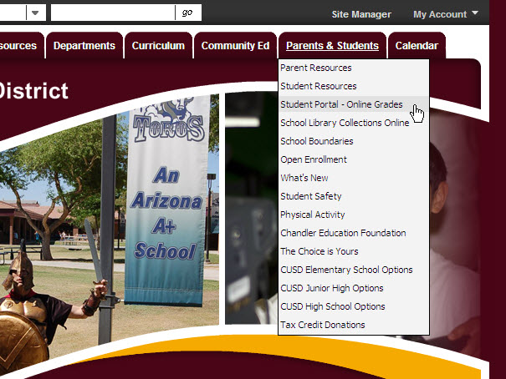
You will need to activate your account. You can logon anywhere you have Internet access (at home, in a school or through your Smartphone). The activation is easy, but you’ll need to follow these directions.
NOTE: You may find it helpful to print these directions now.
How to access:
Go to the Chandler Unified School District homepage: http://www.cusd80.com
- Click on the Parents & Students Tab
- Choose Student Portal-Online Grades
- Click on the Infinite Campus Portal icon

OR

Use this friendly URL:
http://www.cusd80.com/studentportal
The Infinite Campus Portal Homepage appears where you will enter your unique username and password.
Do not choose the options under
First time using Campus Portal?
As a student, you already have a Campus Portal account.
For your User Name, enter:
Capital “S” plus your student number
Example: S78788
For your temporary password, enter:
Capital “S” plus your student number plus
your birthdate (MMDDYY)
Example: S78788051898
Birthdate
(MMDDYY)
Capital
“S”
Student
number
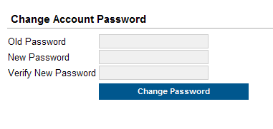
NOW, create your own personalized new password.

Old Password:
This is the password you just used…
Capital “S” plus your student number
plus your birthdate (MMDDYY)

Example: S78788051898

New Password:
Select something easy to remember, but hard for others to guess. NOTE: Your password is case sensitive.
Be sure to keep your password in a safe place, and share it with your parents. Enter your new password into both boxes and click the Change Password button.
If you forget your password, do not try to logon more than twice or the program will be disabled. If your account becomes disabled please contact your school office.



Infinite Campus also offers a FREE Mobile Portal app from any of the following app stores. Access your grades and assignments from anywhere!


