Symbol | Meaning | Example
 | delete
 | close up
 | delete and close up
 | caret | 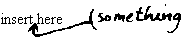
 | insert a space
 | space evenly
 | let stand
 | transpose
used to separate two or more
marks and often as a concluding
stroke at the end of an insertion
 | set farther to the left
 | set farther to the right
 | set as ligature (such as )
 | align horizontally
 | align vertically
 | broken character
 | indent or insert em quad space
 | begin a new paragraph
 | spell out | 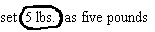
 | set in CAPITALS | 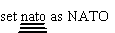
 | set in SMALL CAPITALS
 | set in lowercase
 | set in italic
 | set in roman
 | set in boldface | 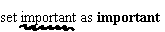
 | hyphen | multi-colored
 | en dash | 1965–72
 | em (or long) dash | Now—at last!—we know.
 | superscript or superior
 | subscript or inferior | 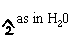
 | centered
 | comma
 | apostrophe
 | period
 | semicolon
 | colon
 | quotation marks
 | parentheses
 | brackets
query to author: has this been
set as intended?
 | push down a work-up
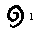 | turn over an inverted letter
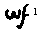 | wrong font

