Name _______________ Pre Calc
Period _________ 4.5 WS #1

Determine the amplitude and period of each function. (Write Period in Radians)

1. y = sin 4x 2. y = cos 5x 3. y = 2 sin x

4. y = –4 sin 3x 5. y = 5 cos 2x 6. y = 3 sin x

Give the amplitude and period of each function graphed below. Then write an equation of each graph.

7. 8.
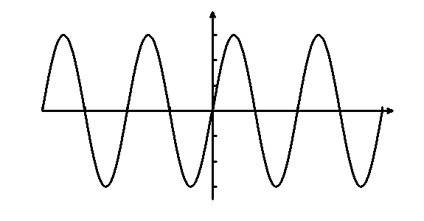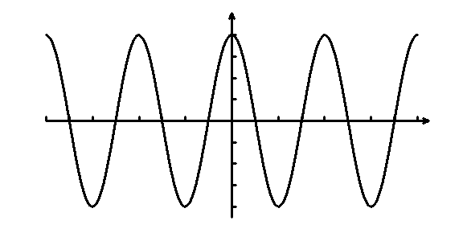
–3
3
2π
π
–π
–2π
4
–4
4π
2π
–2π
–4π

9. 10.
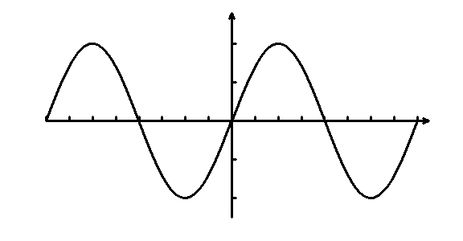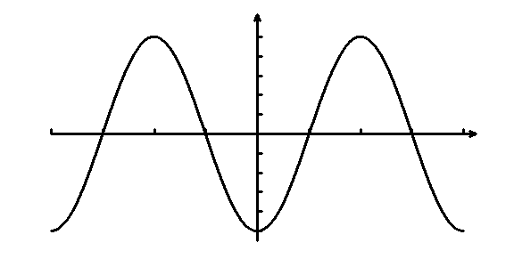
–2
2
4π
2π
–2π
–4π
5
–5
2π
π
–π
–2π

Sketch the graph of the function over the interval –2π ≤ x ≤ 2π.

11. y = 4 sin x 12. y = 2 cos x

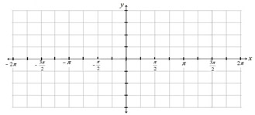

13. y = 2 sin 2x 14. y = – cos 2x

15. y = 3 cos x 16. y = – 2 sin (4x)

