Biology Fall Semester 2018 Final Exam Study Guide

**What do I need to get on the final?**

Quarter 1=40%

Quarter 2= 40%

Final Exam = 20%

A= Current Grade (use semester grade)

B= Percent You Want for Semester

X= Percent Needed on Final

Ex: If my current grade is a 78%, what do I need to get on the exam to have a final grade of 80%?

A=78 B=80

(0.2)X + (0.8)78 = 80

X= 88%

Ex: If my current grade is a 78%, what do I need to get on the exam to have a final grade of 80%?

A=78 B=80

(0.2)X + (0.8)78 = 80

X= 88%

**Section 1: Scientific Process/Method**

1. In designing an experiment, how many dependent/manipulated variables should be tested?

*One dependent/manipulated variable*

1. What is the purpose of a control set-up when designing an experiment?

*Designed to minimize the effects of variables other than the independent variable. Often the “most normal” situation*

1. What is the difference between qualitative and quantitative observations?

*Qualitative observations use your senses to observe the results. (Sight, smell, touch, taste and hear.) Quantitative observations are made with instruments such as rulers, balances, graduated cylinders, beakers, and thermometers. These results are measurable.*

1. “The Isopod has 2 antennae” is an example of which type of observation?

*Quantitative*

1. The “Problem” in an experiment is written in what type of sentence form?

*What is the effect of (independent variable) on (dependent variable)?*

1. A *hypothesis* a possible solution to a problem which can be tested.
2. What is a theory? Can theories change?

*A scientific theory is a well-substantiated explanation of some aspect of the natural world, based on a body of facts that have been repeatedly confirmed through observation and experiment. Theories may change as we develop more knowledge of the natural world.*

**Section 2: Biology as a Science**

1. What is Biology?

*Study of life*

1. What characteristics must an organism have to be considered living?

*Living Things Are Made of Cells, Living Things Respond To Their Environment, Living Things Reproduce, Living Things Use Energy, Living Things Eliminate Waste, Living Things Grow And Mature*

1. Homeostasis is:

*The tendency of the body to seek and maintain a condition of balance or equilibrium within its internal environment, even when faced with external changes. A simple example of***homeostasis is***the body's ability to maintain an internal temperature around 98.6 degrees Fahrenheit, whatever the temperature outside.*

1. The smallest living unit is a *cell.*
2. What tools can a scientist use to see organisms that are not visible to the naked eye?

*Microscopes*

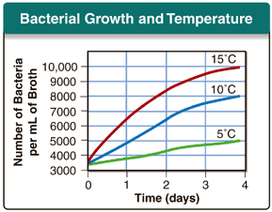

**Section 3: Reading Tables and Graph**s

## Use the following scenario & graph to answer questions 1-4

Bacteria are tiny microorganisms that can reproduce by dividing into two. The graph shows the results of an experiment on the effect of temperature on bacterial reproduction. At the beginning, three populations of bacteria, all of the same type, were of equal size. Each population was kept at a different temperature for 4 days.

1. Classifying What variable did the researcher change during this experiment?

*Temperature*

1. Inferring What do the shapes of the curves tell you about the changes in population size?

*The population initially grew and then leveled off after a few days*

1. Calculating For the bacteria kept at 15°C, how did population size change during the experiment?

*The population size grew the most at 15°C*

1. Drawing Conclusions What effect did the different temperatures have on the growth of the bacterial populations?

# *As the temperature increased the bacteria growth also increased.*

# **Section 4: Chemistry of Life**

1. What are the 3 parts of an atom?

*Neutrons, protons, electrons*

1. What is a polar molecule? Is water polar?

*Polar molecules have a slight positive charge on one side and a slight negative charge on the other. Water is a polar molecule.*

1. List some unique properties of water.

*Adhesion, Cohesion, High specific heat, universal solvent, polar*

1. Why is water important to living cells?

*Water is the solvent that transports many essential molecules and other particles around the body. These include nutrients and waste products from the body's metabolic processes.*

1. What are the “BIG FOUR” macromolecules?

*Carbohydrates, Lipids, Proteins, Nucleic Acids*

1. All organic macromolecules contain the elements *Carbon, Hydrogen and Oxygen*.
2. What molecule makes of most of the cell membrane?

*Lipids*

1. What are enzymes? What do they do? Do they get used up during a reaction?

Enzymes*are a type of protein present in all living things. They are secreted by the source and are biological catalysts, increasing the rate of chemical reactions without undergoing any permanent change themselves.*

1. What is ATP (adenosine triphospahate)?

*It is the high-energy molecule that stores the energy we need to do just about everything we do.*

1. When living cells break down our food molecules, energy is stored as *chemical energy in the form of ATP*
2. What is a covalent bond? (Honors ONLY)

*Bond between two nonmetals where electrons are SHARED.*

1. What is an ionic bond? (HONORS ONLY)

*Bond between a metal and nonmetal where electrons are given and received*

1. Draw and label the pH scale. Where is basic and acidic on that scale? (HONORS ONLY)

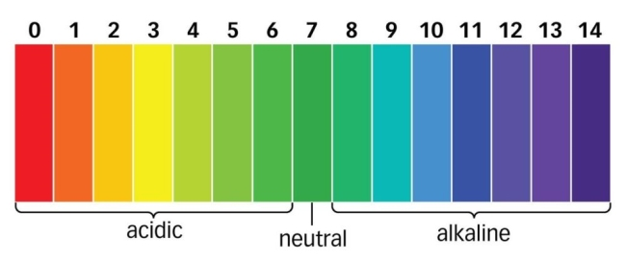

Know the contributions of:

* 1. Robert Hooke

*Robert Hooke's greatest legacy is his contribution to cell theory. Cell theory, as we know it today, is the result of the work of many different scientists. Hooke was actually the first person to view cells under a microscope. Thus, he coined the term 'cell' as it's now used in biology.*

* 1. Anton van Leeuwenhoek

*Van Leeuwenhoek discovered "protozoa" - the single-celled organisms and he called them "animalcules". He also improved the microscope and laid foundation for microbiology.*

1. List the three parts of the cell theory

*All known living things are made up of one or more cells.*

*All living cells arise from pre-existing cells by division.*

*The cell is the fundamental unit of structure and function in all living organisms*

# **Section 5: Cells**

1. Identify the cells types below. Then identify the structures in the cells below:

*Type of cell: animal*

*ribosomes*

Type of cell: *plant*

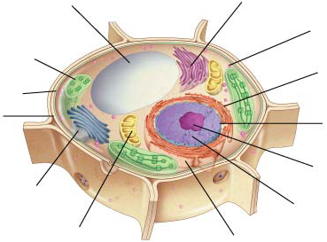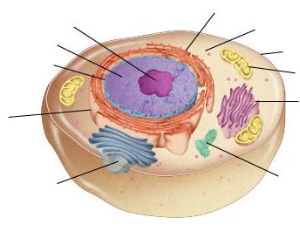

*nucleolus*

*cytoplasm*

*Smooth ER*

*vacuole*

*nucleus*

*ribosomes*

*chloroplast*

*Nuclear*

*membrane*

*Cell membrane*

*Cell membrane*

*mitochondria*

*Rough ER*

*Smooth ER*

*Cell wall*

*Rough ER*

*Nuclear*

*membrane*

*nucleolus*

*centrioles*

*Golgi body*

*Golgi body*

*nucleus*

*mitochondria*

*cytoplasm*

1. What are the functions of the organelles listed in #1 above? (mitochondria, nucleus, chloroplasts, cell membrane, cell wall, etc.)

* *Mitochondria are known as the powerhouses of the cell. They are organelles that act like a digestive system which takes in nutrients, breaks them down, and creates energy rich molecules for the cell*
* *Nucleus: contains the majority of the cell's genetic material. This material is organized as DNA molecules, along with a variety of proteins, to form chromosomes.*
* *Chloroplasts work to convert light energy of the Sun into sugars that can be used by cells. Only found in plant cells*
* *The cell membrane controls the movement of substances in and out of cells and organelles.*
* *Cell* wall: *provides* the **cell** with both structural support and protection. Only found in plant cells

1. What is a prokaryote? What is a eukaryote? Give an example of each.

*Prokaryote- Before nucleus. Organisms without a nucleus such as bacteria.*

*Eukaryote- True nucleus. Organisms with a nucleus in their cells. Example: Plants, animals*

1. How do plant and animal cells **differ**?

*Plant Cells: Have chloroplasts, large central vacuole, and a cell well*

*Animal Cells: Have no chloroplasts, no cell walls, and many smaller vacuoles*

# **Section 6: Cell Transport**

1. What is an isotonic solution?

*Equal concentrations of water inside and outside of cell*

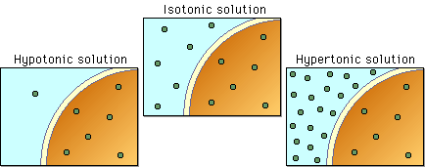

1. What is a hypertonic solution?

*Higher concentration of water inside the cell then outside. Water will move out*



1. What is a hypotonic solution?

*Higher concentration of water outside of the cell. Water will move in*



1. Diffusion is:

*Diffusion is the net passive movement of particles (atoms, ions or molecules) from a region in which they are in higher concentration to regions of lower concentration.*

Osmosis is:

*Osmosis is the net passive movement of WATER from a region in which they are in higher concentration to regions of lower concentration.*

Are these examples of active or passive transport?

*Passive*

Equilibrium is: *When the molecules are even throughout a space*

1. If a mineral too big to pass through the cell membrane is outside of a cell, but is needed inside, how can a cell acquire that mineral? (hint: uses energy)

*Active Transport*

**Cell Reproduction**

1. Compare and contrast asexual and sexual reproduction (think of circles and squares)

Asexual reproduction: *one parent cell splits into 2 identical daughter cells*

***Sexual Reproduction****: a father’s gamete cell (sperm) and a mother’s gamete cell (egg) fuse together to form a zygote*

|  |  |
| --- | --- |
| *Sexual Reproduction* | *Asexual Reproduction* |
| *Advantages:*   * + *Allows for genetic variation*   + *Can result in better species*   *Disadvantages*   * + *Requires partner*   + *Requires special mechanisms* | *Advantages:*   * + *Does not require partner*   + *Generally faster*   + *Requires fewer steps*   *Disadvantages*   * + *Does not allow genetic variation* |

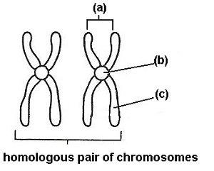

1. Draw and label the parts of a chromosomes.
2. *Chromosomes B- centromere C-Sister Chromatids*

*D- homologous chromosomes*

1. Fill out the chart below regarding mitosis and meiosis.

|  |  |  |
| --- | --- | --- |
|  | **Mitosis** | **Meiosis** |
| Definition | *Mitosis is asexual reproduction of an organism’s non-reproductive cells (somatic cells).* | *Meiosis is cell division that occurs in an organism’s reproductive cells (germ cells)* |
| Type of cell that goes through this process | *Body Cells (ex: Hair, skin, liver, kidney etc.)* | *Gamete Cells/ (ex: egg and sperm)* |
| Number of cells at the end of the process | *Start with 1 original cell and end with 2 cells that are exact copies of one another* | *Start with 1 original cell and end with 4 cells that are each unique* |
| List the Phases, in order, of this process | *Interphase (not part of mitosis but are part of the cell cycle)*  *Prophase*  *Metaphase*  *Anaphase*  *Telophase*  *Cytokinesis (not part of mitosis but are part of the cell cycle)* | *Interphase*  *Prophase I*  *Metaphase I*  *Anaphase I*  *Telophase I*  *Cytokinesis*  *Prophase II*  *Metaphase II*  *Anaphase II*  *Telophase II* |
| End Products | *2 Diploid Iden*  *tical Cells* | *: 4 haploid sperm cells that are each unique* |

1. Which phase of the cell cycle is the longest? Why?

*Interphase is the longest phase in the cell cycle because it that phase, the cell needs to grow, duplicate and replicate chromatin and other parts, and prepare itself for the mitotic phases.*

1. What is meant by genetic variability? What phases of meiosis cause this?

*Genetic variability is the idea that traits or genes vary from organism to organism.*

*Prophase I: Crossing Over*

1. How many pairs of chromosomes do humans have?

*23 pairs of chromosomes or 46 chromosomes*

1. What is a picture of a person’s chromosomes called and what is it used for?

*Karyotype- arrangement of chromosomes from largest to smallest and pairing up the homologous chromosomes. It is used to determine gender and chromosomal abnormalities*

1. What are the chromosomes of a typical male? Female?

Male: *XY* Female: *XX*

1. What are some genetic disorders associated with having too many or two few chromosomes?

*Down Syndrome- Trisomy (extra chromosome) Turner Syndrome-monosomy (missing a chromosome)*

**Bioenergetics (Photosynthesis/Cellular Respiration)**

1. Where do we get the majority of the energy used on Earth from?

*Sun*

1. What is the difference between heterotrophs and autotrophs? Give an example of each.

*Heterotroph: Energy gained from eating (ex: Rabbit, Tiger, Lion, Bear)*

*Autotroph: Energy gained from the sun (ex: Plants, Algea, Bacteria)*

1. Fill out the chart below

|  |  |  |
| --- | --- | --- |
|  | **Photosynthesis** | **Cellular Respiration** |
| Function | *Photosynthesis is the process by which light energy is converted to chemical energy in form of glucose.* | *Cellular respiration is the process that releases energy by breaking down food molecules in the presence of oxygen.* |
| Location | *Chloroplast* | *Mitochondria and cytoplasm* |
| Reactants | *Carbon Dioxide, Water, and Light* | *Glucose and Oxygen* |
| Products | *Glucose and Oxygen* | *Carbon Dioxide, Water, and Energy (ATP)* |
| Equation | *6CO2 + 6H2O🡪 C6H12O6 + 6 O­­2* | *C6H12O6 + 6O­­2 🡪 6CO2 + 6H2O + ATP* |

1. What are the two steps of photosynthesis and what is made in each step?
2. *Light dependent Reaction: In the light reactions, light energy is transformed into ATP and NADPH. This occurs in the thylakoid membranes of the chloroplast. When light hits a chlorophyll molecule, it excites an electron that then travels down an Electron Transport Chain, making ATP and NADPH. Water is split into H+ ions, electrons, and oxygen atoms. O­2­ is released to the atmosphere.*
3. *Light independent Reaction (Calvin Cycle): Also called the Calvin Cycle (named for the scientist who discovered it: Melvin Calvin). In these reactions CO2 is used to build glucose. This takes place in the stroma of the chloroplast. In the Calvin Cycle, CO2 is taken in by the plant. It binds to a molecule called RUBP. Through a series of reactions, glucose is made and RUBP is regenerated.*
4. What is NADPH & why is it important to the process of photosynthesis?

*NADPH is an electron carrier and it provides high energy electrons needed to store energy in organic molecules*

1. Why is chlorophyll green?

*Chlorophyll absorbs light most strong in the blue portion of the electromagnetic spectrum followed by the red portion. It is a poor absorber of green and near-green portions of the spectrum, which it reflects, production the green color of chlorophyll-containing tissues.*

1. What is chromatography? Summarize the procedures.

*Chromatography is a technique that separates mixtures. A solution is used that separates the components of a mixtures. Some components will move further than others which will allow us to see them.*

1. What are the three steps of cellular aerobic respiration? Where do the steps take place?
2. *Glycolysis in the Cytosol/Cytoplasm 2. Krebs Cycle in the Mitochondrial Matrix 3. Electron Transport Chain in the Inner Mitochondria Membrane*
3. What is the difference between anaerobic and aerobic respiration? How much ATP is produced in each type of respiration?

*Anaerobic: Does not require oxygen and only 2 ATP are produced*

*Aerobic: Requires oxygen and 32-38 ATP are produces*

1. Give two examples of aerobic respiration and explain what is produced with each of these.

*Krebs cycle produces CO2 and H2O*

*Electron Transport chain produces ATP*

1. What is the relationship between cellular respiration and photosynthesis?

*In Photosynthesis, plants use the sun's energy as light to transform carbon dioxide and water into glucose. In cellular respiration, glucose is ultimately broken down to yield carbon dioxide and water, and the energy from this process is stored as ATP molecules.*

1. Do cells produce more ATP when oxygen is present or absent? Explain why.

*More ATP is produced in the presence of oxygen because pyruvate can be converted into CO­2­, Water and ATP in the Krebs Cycle. From there ATP synthase in the ETC can convert ADP to ATP creating much more ATP.*

1. Which organisms perform cellular respiration? Photosynthesis?

*Photosynthesis: Plants, Algae, Bacteria (Autotrophs)*

*Cellular Respiration: Heterotrophs and Plants*

**Molecular Genetics**

1. List 4 famous scientists famous for their work with DNA.

*Frederick Griffith and Oswald Avery- Griffith discovered transformation- that “something hereditary” could be transferred between organisms and Avery discovered that DNA was the transforming agent*

*Edwin Chargaff- A=T, G=C*

*Alfred Hershey and Martha Chase- DNA was the molecule of heredity*

*Rosalind Franklin- Used X-Ray technology to create Photo 51 which helped identify the structure of DNA*

*James Watson and Francis Crick- Credited with the discovery of the structure of DNA*

1. What is DNA? Where is DNA found? DNA is in what types of organisms? What is the function of DNA? What is the shape of DNA? What is DNA composed of?

*DNA= Deoxyribonucleic Acid and it is the molecule of heredity that stores genetic data*

*DNA is found mainly in the nucleus*

*DNA is found in both eukaryotic and prokaryotic cells*

*DNA stores genetic data*

*DNA is considered double helix*

*DNA is composed of a sugar phosphate backbone with nitrogenous bases as the steps of the ladder*

1. A model of a DNA molecule is shown below. The arrow indicates what type of bond –

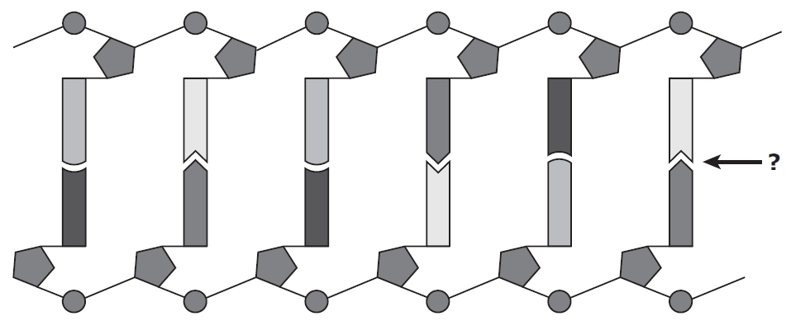

*Hydrogen Bonds connecting the nucleotides*

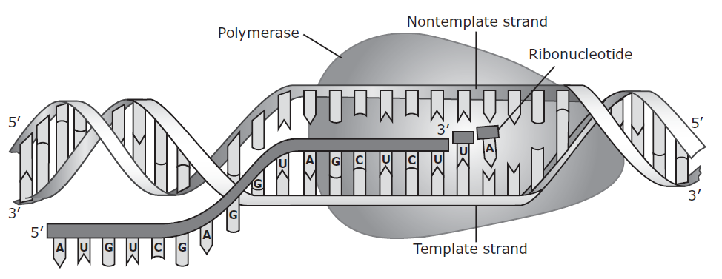

1. The process represented in the diagram produces a molecule that is complementary to the template strand of DNA. What type of molecule is produced?

*A molecule of mRNA is produced which will eventually lead to the formation of a protein.*

1. What are the main steps of DNA replication & the names of the enzymes that do them?
   1. ***Helicase:*** *unwinds DNA at origins of replication*
   2. *Initiation proteins separate 2 strands 🡪 forms replication bubble*
   3. ***Primase:*** *puts down RNA primer to start replication*
   4. ***DNA polymerase III:*** *adds complimentary bases to leading strand (new DNA is made 5’ 🡪 3’)*
   5. *Lagging strand grows in 3’🡪5’ direction by the addition of Okazaki fragments*
   6. ***DNA polymerase I:*** *replaces RNA primers with DNA*
   7. ***DNA ligase:*** *seals fragments together*
2. Why is accurate DNA replication important? What is it called when replication “messes up”? What are the main types of mistakes that occur during DNA replication?

*DNA is the template for Protein Synthesis so if there are any mistakes then proteins will not be made correctly. When DNA “messes up” it is called a mutation.*

*Types of mutations include:*

* + - *Frameshift mutations (insertion or deletion)*
    - *Substitution (nonsense, silent or amino acid change)*

1. DNA is made of what 4 nucleotide bases? How do the DNA bases pair up?

Adenine (A)

Thymine (T)

Guanine (G)

Cytosine (C)

A-T C-G

1. Which bases are purines? Pyrimidines? Sketch their shapes.

Purines: Adenine and Guanine

Pyrimidines: Thymine and Cytosine

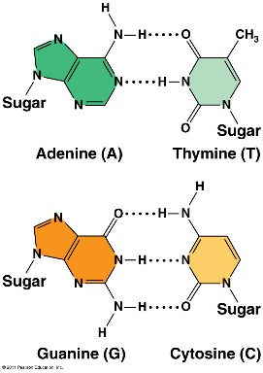

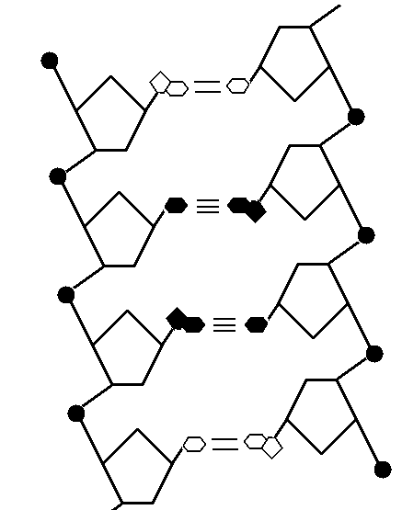

**A**

**B**

**C**

**D**

1. Label each of the parts of the DNA molecule above (A-D).

*A: Sugar*

*B: Phosphate  
C: Nucleotide*

*D: Hydrogen Bond*

1. What is mRNA? How is base pairing from DNA to RNA the same as DNA to DNA? How is it different?

*mRNA is messenger RNA and serves as a messenger for making proteins.*

*Guanine- Cytosine*

*Adenine-Uracil (not Thymine)*

1. Compare and Contrast DNA and RNA.

|  |  |  |
| --- | --- | --- |
|  | **DNA** | **RNA** |
| *Structure* | *Typically a double- stranded molecule with a long chain of nucleotides* | *A single-stranded molecule in most of its biological roles and has a shorter chain of nucleotides* |
| *Base Pairing* | *A-T(Adenine-Thymine), G-C(Guanine-Cytosine)* | *A-U(Adenine-Uracil), G-C(Guanine-Cytosine)* |
| *Difference* | *1.Found in nucleus 2. sugar is deoxyribose 3. Bases are A,T,C,G* | *1.Found in nucleus and cytoplasm 2.sugar is ribose. 3. Bases are A,U,C,G* |
| *Definition* | *A nucleic acid that contains the genetic instructions used in the development and functioning of all known living organisms* | *RNA, single-stranded chain of alternating phosphate and ribose units with the bases adenine, guanine, cytosine, and uracil bonded to the ribose. RNA molecules are involved in protein synthesis and sometimes in the transmission of genetic information.* |
| *Job/Role* | *Medium of long-term storage and transmission of genetic information* | *The main job of RNA is to transfer the genetic code need for the creation of proteins from the nucleus to the ribosome. this process prevents the DNA from having to leave the nucleus, so it stays safe. Without RNA, proteins could never be made.* |

1. What is the sequence of nucleotides that you would find on the complimentary strand of this DNA?

**T A C G C G T T T C A**

**A T G C G C A A A G T**

1. What are the two main steps of protein synthesis? Where do they happen in the cell?

*Transcription: DNA to mRNA in the nucleus*

*Translation: mRNA to a chain of amino acids which will fold into a protein. This occurs in the cytoplasm and ribosome*

1. What is the sequence of nucleotides that you would find on the properly transcribed **mRNA** of this DNA?

**T A C A A A T C G C C G A C T**

**A U G U U U A G C G G C U G A**

1. 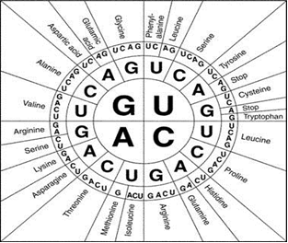Use the codon wheel and the transcribed mRNA sequence above to translate & determine the sequence of amino acids the DNA strand codes for?

*AUG: Start*

*UUU: Phenylalanine*

*AGC: Serine*

*GGC: Glycine*

*UGA: Stop*

1. The sequence of amino acids above is bonded together to form what type of molecule?

*Protein*

1. How can mutations be harmful to living organisms?

*Change the amino acid sequence which can cause the protein to not fold properly and overall not function properly.*

1. Are all mutations harmful?

*No- More than one codon can code for the same amino acid so if the mutation causes the same amino acid to be created then there will be no change in the protein being made- This is a silent mutation.*