

**Activity 4.5 Motion in One Direction**

Introduction

Motion is a change in position over time. We describe motion using terms such as distance, displacement, speed and velocity. Kinematics is the science of describing the motion of objects using words, diagrams, numbers, graphs, and equations.

In this activity you will interpret words and diagrams describing motion in order to graphically model the motion using a motion graph. Inversely you will interpret a graphical model of motion and describe the motion represented in words. You will also represent the motion using numbers (and direction, when applicable) to indicate the magnitude of distance, displacement, speed and velocity.

Equipment

* Engineering notebook
* Computer with spreadsheet software

Procedure

After school, a student jogged from school to the library. It took the student 35 minutes to get to the library, where he spent 10 minutes browsing and checking out a book. He then walked to the coffee shop, on the same street, in 15 minutes. He spent 40 minutes sitting at a table in the coffee cafe and reading the book before heading home. He walked home in 25 minutes and remained there until the next morning.

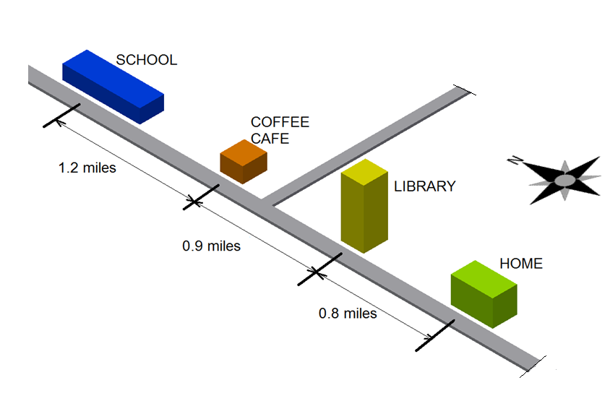

1. Use the distances shown in the diagram above to draw a motion graph of the student along the street, in which he begins walking from school to the library at   
   t = 0 minutes. Show 2.5 hours of time after he left school. Be sure to include axis labels, scales, and units.

Assume that a positive displacement is from school toward home.



1. Using your motion graph, answer each of the following.
   * What is the student’s displacement after 1.5 hours? Plot a point on your graph to correspond to this position and label it “Point A”.
   * What is the total distance the student had walked after an hour and a half?
   * What was the student’s displacement at 1 hour and 50 minutes? Plot a point on your graph to correspond to this position and label it “Point C”.
   * What is the total distance the student had walked when he arrived home?
   * At what speed (in miles per hour) was the student walking 20 minutes after he left school?
   * If home is due South of school, what is the velocity of the student at   
     t = 50 minutes? Give the magnitude of velocity in miles per hour.
   * What is the student’s speed at t = 1 hour?
2. The following graph represents the vertical motion of a ball thrown straight up into the air.

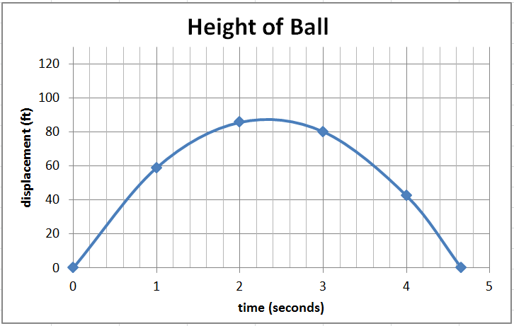

Using the motion graph, answer the following. Show your work or explain your answer.

* + What is the displacement of the ball at t = 4 seconds?
  + What is the total distance the ball has traveled at t = 3 seconds?
  + What is the average speed of the ball between t = 0 and t = 2 seconds?
  + What is the average velocity of the ball between t =3 and t = 4 seconds?
  + How long did it take before the ball returned to its original height?

1. Create a motion graph, but do not define the units or scales for the graph. Exchange your motion graph with a classmate.
   * Write a story or a description of a scenario that might be represented by your partner’s graph.
   * Label the axes, show scales and units for the graph.

**Conclusion Questions**

1. Look at the motion graph that you created in item 1 to graphically represent the displacement of a student with respect to time. This graph represents motion in one direction along a straight line (the street). Why is the graph NOT a straight line?
2. Look at the motion graph provided in item 3. This graph represents the displacement of a ball thrown vertically up into the air. Create a sketch that illustrates the actual path of the ball (as if captured with a long exposure photograph so that the ball appears as a blurry line). Why does the motion graph (displacement versus time) have a different shape than the path of the ball?
3. The motion graph represented in item number three is a parabola. We can represent this function mathematically with the quadratic equation

d(t) = -16.1t2 + 75t

where d(t) represents the vertical displacement in feet and t represents time in seconds.

Using the mathematical equation, predict the position of the ball when t = 2 seconds. Show your work.

Your prediction should match the motion graph. If not, double check your work.