Chapter 2
KINEMATICS IN ONE DIMENSION
PREVIEW
Kinematics is the study of how things move – how far (distance and displacement), how
fast (speed and velocity), and how fast that how fast changes (acceleration). We say that
an object moving in a straight line is moving in one dimension, and an object which is moving in a curved path (like a projectile) is moving in two dimensions. We relate all these quantities with a set of equations called the kinematic equations.

The content contained in all sections of chapter 2 of the textbook is included on the AP Physics B exam.

QUICK REFERENCE
Important Terms

acceleration
the rate of change in velocity
acceleration due to gravity
the acceleration of a freely falling object in the absence of air resistance, which near the earth’s surface is approximately 10 m/s² .
acceleration-time graph
plot of the acceleration of an object as a function of time
average acceleration
the acceleration of an object measured over a time interval
average velocity
the velocity of an object measured over a time interval; the displacement of an object divided by the change in time during the motion
constant (or uniform) acceleration
acceleration which does not change during a time interval
constant (or uniform) velocity
velocity which does not change during a time interval
displacement
change in position in a particular direction (vector)
distance
the length moved between two points (scalar)
free fall
motion under the influence of gravity
initial velocity
the velocity at which an object starts at the beginning of a time interval

instantaneous
the value of a quantity at a particular instant of time, such as instantaneous position, velocity, or acceleration
kinematics
the study of how motion occurs, including distance, displacement, speed, velocity, acceleration, and time.
position-time graph
the graph of the motion of an object that shows how its position varies with time
speed
the ratio of distance to time
velocity
ratio of the displacement of an object to a time interval
velocity-time graph
plot of the velocity of an object as a function of time, the slope of which is acceleration, and the area under which is displacement

Equations and Symbols

$$\begin{aligned}a=\frac{v−v_{o}}{t} \\ v=v_{o}+\text{at} \\ Δx=\frac{1}{2}(v_{o}+v)t \\ Δx=v_{o}t+\frac{1}{2}{\text{at}}^{2} \\ v^{2}=v_{o^{2}}+2aΔx\end{aligned}$$
where

Δx = displacement (final position – initial
position)
v = velocity or speed at any time
v_{o} = initial velocity or speed
t = time
a = acceleration

Ten Homework Problems

Chapter 2 Problems 2, 10, 13, 30, 40, 43, 58, 59, 73, 78
DISCUSSION OF SELECTED SECTIONS

2.1 Displacement
Distance d can be defined as total length moved. If you run around a circular track, you have covered a distance equal to the circumference of the track. Distance is a scalar, which means it has no direction associated with it. Displacement Δx, however, is a vector. Displacement is defined as the straight-line distance between two points, and is a vector which points from an object’s initial position x_{o} toward its final position x_{f}. In our previous example, if you run around a circular track and end up at the same place you started, your displacement is zero, since there is no distance between your starting point and your ending point. Displacement is often written in its scalar form as simply Δx or x.
2.2 Speed and Velocity
Average speed is defined as the amount of distance a moving object covers divided by the amount of time it takes to cover that distance:
average speed = v $=\frac{\text{ distance}}{\text{elapsed} \text{time}}=\frac{d}{t}$
where v stands for speed, d is for distance, and t is time.
Average velocity is defined a little differently than average speed. While average speed is the total change in distance divided by the total change in time, average velocity is the displacement divided by the change in time. Since velocity is a vector, we must define it in terms of another vector, displacement. Oftentimes average speed and average velocity are interchangeable for the purposes of the AP Physics B exam. Speed is the magnitude of velocity, that is, speed is a scalar and velocity is a vector. For example, if you are driving west at 50 miles per hour, we say that your speed is 50 mph, and your velocity is 50 mph west. We will use the letter v for both speed and velocity in our calculations, and will take the direction of velocity into account when necessary.
2.3 Acceleration
Acceleration tells us how fast velocity is changing. For example, if you start from rest on the goal line of a football field, and begin walking up to a speed of 1 m/s for the first second, then up to 2 m/s, for the second second, then up to 3 m/s for the third second, you are speeding up with an average acceleration of 1 m/s for each second you are walking. We write
$$a=\frac{Δv}{Δt}=\frac{1 m/s}{1s}=1 {m/s}/s=1 \frac{m}{s^{2}}$$
In other words, you are changing your speed by 1 m/s for each second you walk. If you start with a high velocity and slow down, you are still accelerating, but your acceleration would be considered negative, compared to the positive acceleration discussed above.
Usually, the change in speed Δv is calculated by the final speed v_{f} minus the initial speed v_{o}. The initial and final speeds are called instantaneous speeds, since they each occur at a particular instant in time and are not average speeds.

2.5 Applications of the Equations of Kinematics for Constant

Acceleration
Kinematics is the study of the relationships between distance and displacement, speed and velocity, acceleration, and time. The kinematic equations are the equations of motion which relate these quantities to each other. These equations assume that the acceleration
of an object is uniform, that is, constant for the time interval we are interested in. The kinematic equations listed below would not work for calculating velocities and displacements for an object which is accelerating erratically. Fortunately, the AP Physics B exam generally deals with uniform acceleration, so the kinematic equations listed above will be very helpful in solving problems on the test.

2.6 Freely Falling Bodies
An object is in free fall if it is falling freely under the influence of gravity. Any object, regardless of its mass, falls near the surface of the Earth with an acceleration of 9.8 m/s², which we will denote with the letter g. We will round the free fall acceleration g to 10 m/s² for the purpose of the AP Physics B exam. This free fall acceleration assumes that there is no air resistance to impede the motion of the falling object, and this is a safe assumption on the AP Physics B test unless you are told differently for a particular question on the exam.
Since the free fall acceleration is constant, we may use the kinematic equations to solve problems involving free fall. We simply need to replace the acceleration a with the specific free fall acceleration g in each equation. Remember, anytime a velocity and acceleration are in opposite directions (like when a ball is rising after being thrown upward), you must give one of them a negative sign.

Example 1 A girl is holding a ball as she steps onto a tall elevator on the ground floor of a building. The girl holds the ball at a height of 1 meter above the elevator floor. The elevator begins accelerating upward from rest at 3 m/s². After the elevator accelerates for 5 seconds, find

(a) the speed of the elevator
(b) the height of the floor of the
elevator above the ground.

At the end of 5 s, the girl lets go of the ball from a height of 1 meter above the floor of the elevator. If the elevator continues to accelerate upward at 3 m/s², describe the motion of the ball
(c) relative to the girl’s hand,
(d) relative to the ground.

(e) Determine the time after the ball is released that it will make contact with the floor.

(f) What is the height above the ground of the ball and floor when they first make contact?

Solution:
(a) $v=v_{o}+\text{at}=0+\left(3 m/{s^{2}}\right)\left(5s\right)=\text{15} m/s \text{upward}$
(b) $y=v_{o}t+\frac{1}{2}{\text{at}}^{2}=0+\frac{1}{2}\left(3 m/{s^{2}}\right){\left(5 s\right)}^{2}=\text{37}\text{.}5 m$
(c) When the girl releases the ball, both she and the ball are moving with a speed of 15 m/s upward. However, the girl continues to accelerate upward at 3 m/s², but the ball ceases to accelerate upward, and the ball’s acceleration is directed downward at g = 10 m/s², that is, it is in free fall with an initial upward velocity of 15 m/s. Therefore the ball will appear to the girl to fall downward with an acceleration of 3 m/s² – (- 10 m/s²) = 13 m/s² downward, and will quickly fall below her hand.

(d) Someone watching the ball from the ground would simply see the ball rising upward with an initial velocity of 15 m/s, and would watch it rise to a maximum height, at which point it would be instantaneously at rest (provided it doesn’t strike the floor of the elevator before it reaches its maximum height).

(e) When the ball is released, it is traveling upward with a speed of 15 m/s, has a downward acceleration of 13 m/s² relative to the floor, and is at a height y = 1 m above the floor. The time it takes to “fall” to the floor is

$$\begin{aligned}y=\frac{1}{2}{\text{at}}^{2} \\ 1 m=\frac{1}{2}\left(\text{13} m/{s^{2}}\right)t^{2} \\ t=0\text{.}4 s\end{aligned}$$

(f) In this time of 0.4 s, the elevator floor has moved up a distance of
$$Δy=\frac{1}{2}a_{e}t^{2}=\frac{1}{2}\left(3 m/{s^{2}}\right){\left(0\text{.}4s\right)}^{2}=0\text{.}\text{24} m$$

Thus, the ball and elevator floor collide at a height above the ground of
37.5 m + 0.24 m = 37.74 m.

2.7 Graphical Analysis of Velocity and Acceleration
Let’s take some time to review how we interpret the motion of an object when we are given the information about it in graphical form. On the AP Physics B exam, you will need to be able to interpret three types of graphs: position vs.time, velocity vs. time, and acceleration vs. time.
Position vs. time
Consider the position vs. time graph below:
x (m)
t (s)
Δx
Δt
P
x (m)
t (s)
Δx
Δt
The slope of the graph on the left is $\frac{Δx}{Δt}$, and is therefore velocity. The curved graph on the right indicates that the slope is changing. The slope of the curved graph is still
velocity, even though the velocity is changing, indicating the object is accelerating. The instantaneous velocity at any point on the graph (such as point P) can be found by drawing a tangent line at the point and finding the slope of the tangent line.
Velocity vs. time
Consider the velocity vs. time graph below:
v (m/s)
t (s)
Δv
Δt
v (m/s)
t (s)
Area

As shown in the figure on the left, the slope of a velocity vs. time graph is $\frac{Δv}{Δt}$, and is therefore acceleration. As shown on the figure on the right, the area under a velocity vs. time graph would have units of $\frac{m}{s} \left(s\right)=m$, and is therefore displacement.
Acceleration vs. time
Since the AP Physics B exam generally deals with constant acceleration, any graph of acceleration vs. time on the exam would likely be a straight horizontal line:
a (m/s²)
0
t(s)
+5 m/s²
a (m/s²)
0
t(s)
-5 m/s²
This graph on the left tells us that the acceleration of this object is positive. If the object were accelerating negatively, the horizontal line would be below the time axis, as shown in the graph on the right.

Example 2 Consider the position vs. time graph below representing the motion of a car. Assume that all accelerations of the car are constant.
x(m)
t(s)
A
B
C
D
E
F
G
H
I
J
K
0

On the axes below, sketch the velocity vs. time and acceleration vs. time graphs for this
car.
v(m/s)
t(s)
0

a(m/s²)
t(s)
0

Solution:
The car starts out at a distance behind our reference point of zero, indicated on the graph as a negative displacement. The velocity (slope) of the car is initially positive and constant from points A to C, with the car crossing the reference point at B. Between points C and D, the car goes from a high positive velocity (slope) to a low velocity, eventually coming to rest (v = 0) at point D. At point E the car accelerates positively from
rest up to a positive constant velocity from points F to G. Then the velocity (slope) decreases from points G to H, indicating the car is slowing down. It is between these two points that the car’s velocity is positive, but its acceleration is negative, since the car’s velocity and acceleration are in opposite directions. The car once again comes to rest at point H, and then begins gaining a negative velocity (moving backward) from rest at
point I, increasing its speed negatively to a constant negative velocity between points J and K. At K, the car has returned to its original starting position.

The velocity vs. time graph for this car would look like this:
v(m/s)
t(s)
0
A
B
C
D
E
F
G
H
I
J
K

The acceleration vs. time graph for this car would look like this:

a(m/s²)
t(s)
0
A
B
C
D
E
F
G
H
I
J
K

CHAPTER 2 REVIEW QUESTIONS
For each of the multiple choice questions below, choose the best answer.
Unless otherwise noted, use g = 10 m/s² and neglect air resistance.

1. Which of the following statements is true?
- Displacement is a scalar and distance is a vector.
- Displacement is a vector and distance is a scalar.
- Both displacement and distance are vectors.
- Neither displacement nor distance are vectors.
- Displacement and distance are always equal.

2. Which of the following is the best statement for a velocity?
- 60 miles per hour
- 30 meters per second
- 30 km at 45° north of east
- 40 km/hr
- 50 km/hr southwest

3. A jogger runs 4 km in 0.4 hr, then 8 km in 0.8 hr. What is the average speed of the jogger?
- 10 km/hr
- 3 km/hr
- 1 km/hr
- 0.1 km/hr
- 100 km/hr

4. A motorcycle starts from rest and accelerates to a speed of 20 m/s in a time of 8 s. What is the motorcycle’s average acceleration?
- 160 m/s²
- 80 m/s²
- 8 m/s²
- 2.5 m/s²
- 0.4 m/s²

5. A bus starting from a speed of +24 m/s slows to 6 m/s in a time of 3 s. The average acceleration of the bus is
- 2 m/s²
- 4 m/s²
- 6 m/s²
- – 2 m/s²
- – 6 m/s²

6. A train accelerates from rest with an acceleration of 4 m/s² for a time of 20 s. What is the train’s speed at the end of 20 s?
- 0.25 m/s
- 4 m/s
- 2.5 m/s
- 0.8 m/s
- 80 m/s

7. A football player starts from rest 10 meters from the goal line and accelerates away from the goal line at 5 m/s². How far from the goal line is the player after 4 s?
- 6 m
- 30 m
- 40 m
- 50 m
- 60 m

8. A ball is dropped from rest. What is the acceleration of the ball immediately after it is dropped?
- zero
- 5 m/s²
- 10 m/s²
- 20 m/s²
- 30 m/s²

Questions 9 – 11:
A ball is thrown straight upward with a speed of +12 m/s.

9. What is the ball’s acceleration just after it is thrown?
- zero
- 10 m/s² upward
- 10 m/s² downward
- 12 m/s² upward
- 12 m/s² downward

10. How much time does it take for the ball to rise to its maximum height?
- 24 s
- 12 s
- 10 s
- 2 s
- 1.2 s

11. What is the approximate maximum height the ball reaches?
- 24 m
- 17 m
- 12 m
- 7 m
- 5 m

12. Which two of the following pairs of graphs are equivalent?
(A)
x
t
v
t
0

(B)
x
t
v
t

0

(C)
x
t
v
t

0

(D)
x
t
v
t

0

x
t
v
t
(E)
0

Questions 13 – 14:
Consider the velocity vs time graph below:

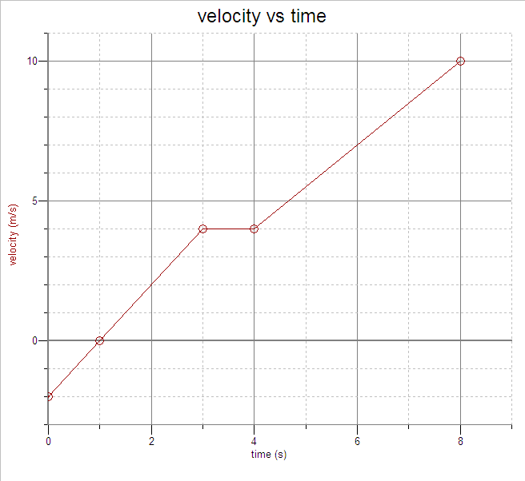

13. A which time(s) is the object at rest?
- zero
- 1 s
- 3 s to 4 s
- 4 s only
- 8 s

14. During which interval is the speed of the object decreasing?
- 0 to 1 s
- 1 s to 3 s
- 3 s to 4 s
- 4 s to 8 s
- the speed of the object is never decreasing in this graph

Free Response Question

Directions: Show all work in working the following question. The question is worth 15 points, and the suggested time for answering the question is about 15 minutes. The parts within a question may not have equal weight.

1. (15 points)
A cart on a long horizontal track can move with negligible friction to the left or to the right. During the time intervals when the cart is accelerating, the acceleration is constant. The acceleration during other time intervals is also constant, but may have a different value. Data is taken on the motion of the cart, and recorded in the table below.

Displacement x(m) | Velocity  v(m/s) | time  t(s)
2 | - 4 | 0
 | - 2 | 1
 | - 2 | 2
 | - 2 | 3
 | 1 | 6
 | 1 | 7
 | 0 | 9
 | 0 | 10

(a) Plot these data points on the v vs t graph below, and draw the best-fit straight lines between each data point, that is, connect each data point to the one before it. The acceleration is constant or zero during each interval listed in the data table.

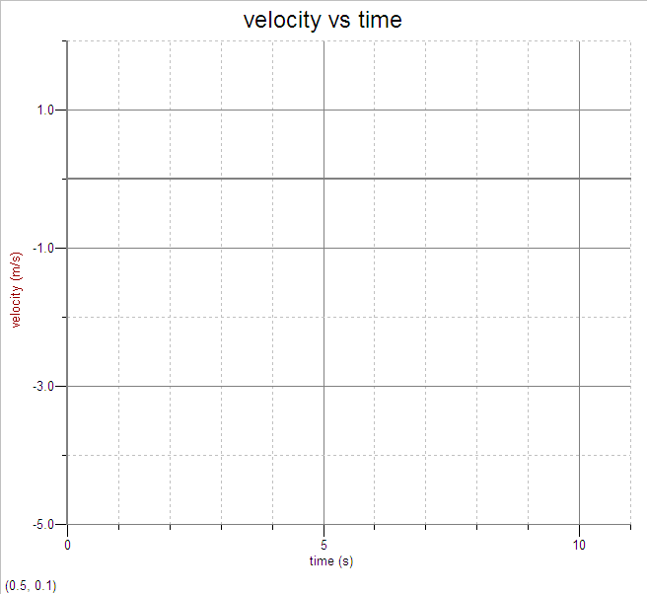

(b) List all of the times between t = 0 and t = 10 s at which the cart is at rest.

(c) i. During which time interval is the magnitude of the acceleration of the cart the
greatest?
ii. What is the value of this maximum acceleration?

(d) Find the displacement of the cart from x = 0 at a time of 10 s.

(e) On the following graph, sketch the acceleration vs. time graph for the motion of this cart from t = 0 to t = 10 s.
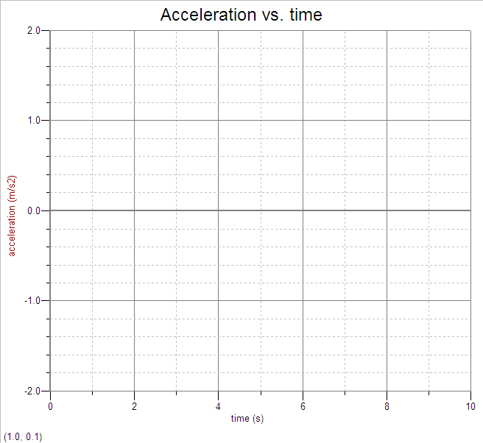

ANSWERS AND EXPLANATIONS TO CHAPTER 2 REVIEW QUESTIONS

Multiple Choice

1. B
Displacement is the straight-line length from an origin to a final position and includes direction, whereas distance is simply length moved.

2. E
Velocity is a vector and therefore direction should be included.

3. A
Average speed is total distance divided by total time. The total distance covered by the jogger is 12 km and the total time is 1.2 hours, so the average speed is 10 km/hr.

4. D
$$a=\frac{Δv}{Δt}=\frac{\text{20} m/s}{8 s}=2\text{.}5\frac{m}{s^{2}}$$

5. E
$$a=\frac{v_{f}−v_{o}}{t}=\frac{6 m/s−\text{24} m/s}{3 s}= − 6\frac{m}{s^{2}}$$

6. E
$$v_{f}=v_{i}+\text{at}=0+\left(4 m/{s^{2}}\right)\left(\text{20} s\right)=\text{80} m/s$$
7. D
$$x_{f}=x_{o}+v_{o}t+\frac{1}{2}{\text{at}}^{2}=(\text{10} m)+0+\frac{1}{2}\left(5\frac{m}{s^{2}}\right){\left(4s\right)}^{2}=\text{50} m$$

8. C
The acceleration due to gravity is 10 m/s² at all points during the ball’s fall.

9. C
After the ball is thrown, the only acceleration it has is the acceleration due to gravity, 10 m/s².

10. E
At the ball’s maximum height, v_{f} = 0. Thus,
$\begin{aligned}v_{f}=v_{o}−\text{gt}=0 \\ t=\frac{\text{12} m/s}{\text{10} m/{s^{2}}}=1\text{.}2 s\end{aligned}$

11. D
$$y=\frac{1}{2}{\text{gt}}^{2}=\frac{1}{2}\left(\text{10} \frac{m}{s^{2}}\right){\left(1\text{.}2 s\right)}^{2}=7\text{.}2 m≈7 m$$

12. B
Both of these graphs represent motion that begins at a high positive velocity, and slows down to zero velocity.

13. B
The line crosses the axis (v = 0) at a time of 1 second.

14. A
The object begins with a high negative (backward) velocity at t = 0, then its speed decreases to zero by a time of 1 s.
Free Response Question Solution
(a) 4 points

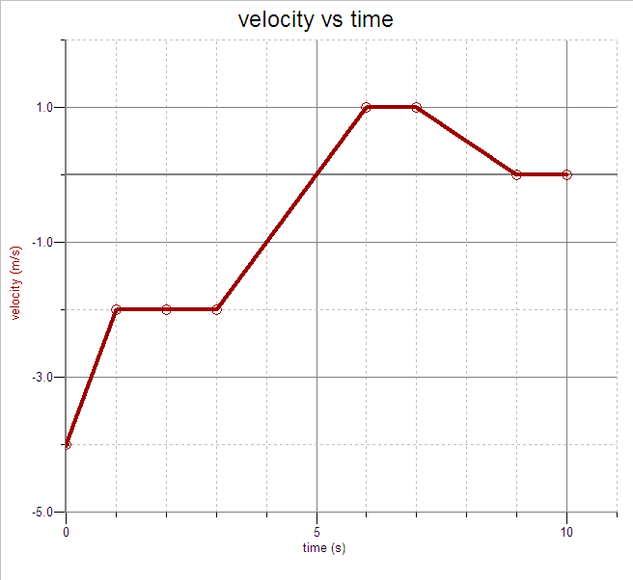

(b) 2 points
The cart is at rest when the velocity is zero, that is, when the graph crosses the time axis. Thus, v = 0 at 5 s, 9 s, and 10 s, as well as all points between 9 and 10 s.

(c) i. 1 point
The acceleration can be found by finding the slope of the v vs t graph in a particular interval. The slope (acceleration) is maximum (steepest) in the time interval from 0 to 1 s.

ii. 2 points
Acceleration = slope of v vs t graph = $\frac{−2 m/s−\left(−4 m/s\right)}{1s−0s}=2 m/{s^{2}}$

(d) 3 points
The displacement of the cart from x = 0 can be found by determining the area under the graph. Note that the area is negative from 0 to 5 s, and positive from 5 s to 9 s. Don’t forget the initial displacement of 2 m at t = 0.

Area from 0 to 5 s = 10 squares = - 10 m.
Area from 5 to 10 s = 2.5 squares = +2.5 m

Total displacement from x = 0 is 2 m – 10 m + 2.5 m = - 5.5 m.
(e) 3 points
