Riggs Jingle Jog
Thursday, December 19th, 2024


1st – 3rd Jingle Jog at 9:00 a.m.
Kindergarten Jingle Jog at 10:30 a.m.
(Kindergarten stays on campus)
4th – 6th Jingle Jog at 1:50 p.m.

The Riggs Physical Education Department welcomes your participation in our winter fun run. This event is being presented to promote the physical fitness and health of the entire Riggs community. Parents and guests are welcome to run or walk with the students. We could always use lots of donated fruit flavored candy canes for the event!!

1st – 6th grade course
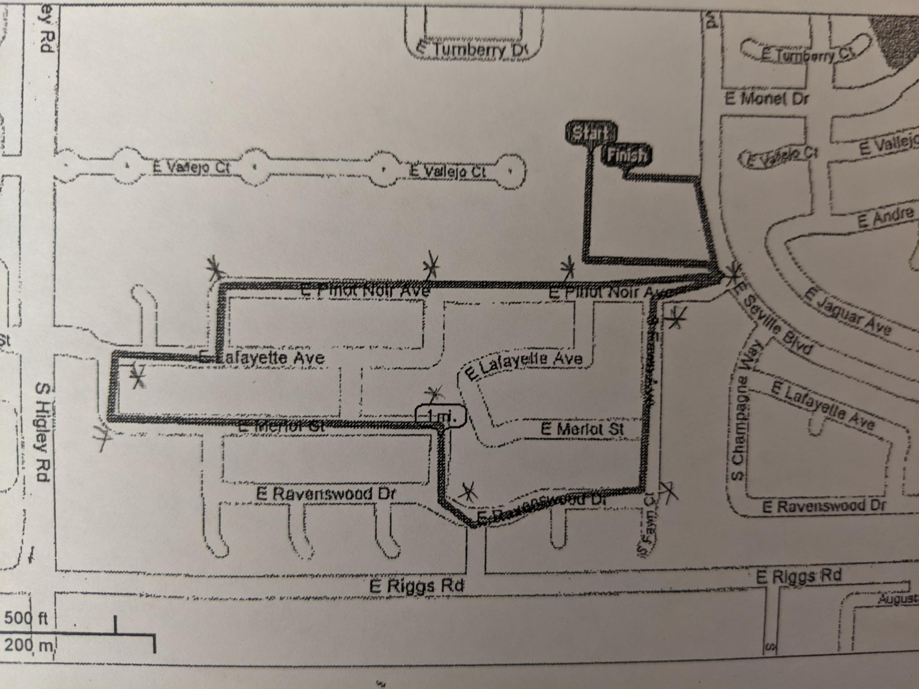

.

Who: The Jingle Jog / Winter Walk is open to parents, teachers, students and guests.
Where: Riggs Neighborhood
How far: 1.5 miles
Shirts: If interested, orders must be done ONLINE ONLY by DECEMBER 6th!
https://createdimages.com/product/riggs-jingle-jog-24-short-sleeve-tee/

1st – 6th grade - return signed portion below to your child’s teacher

I give my son/daughter _____________________________________________________
Permission to participate in the Jingle Jog and run off campus on December 19th. He/she has no known medical problems that would prevent him/her from participating.

Parent Signature______________________ Date_______ Teacher’s name_________________

I plan on running with my child

