Proof for the kinetic and potential energies for a mass on a spring

Using the equation for the position of a mass on a spring, we will solve for the potential and kinetic energy for the system.

I am selecting to use the sine solution to solve for PE and KE.

PE:

Now the KE:

Remembering that velocity is the derivative of position with respect to time…

Remember our definition of

If you start with the other equation (the cosine one) you get similar answers except you get cosine for PE and sine for KE. These results should make sense because if the PE and KE are such that one is sine while the other is cosine, then they will always be out of phase by radians. If this is the case, then every time the KE is at a maximum value, the PE will be zero, and every time the PE is at a maximum value, the KE will be zero.

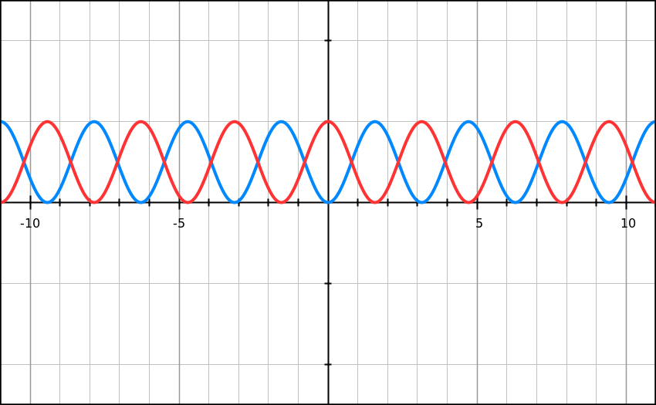

*\*The red line is the PE and the blue line is the KE . Notice that whenever one is at its peak the other is at zero.*

Writing the equation for the total energy:

From the trig identity of