Energy Hare-y

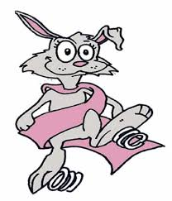

My Superflex Strategies!

* 15 Wall push-ups – back of room
* 15 Jumping Jacks – back of room
* Use my fidget
* Take a walk

(Cut out and tape to desk – or reference in room somewhere)