 **When I feel angry, I can:**

1. Use my Superflex strategies. I can get away from the person who is making me mad and hold my words in my mouth. If I am at home, I can go to another room and hold my words in.

  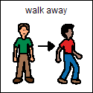



2. I can use words to tell teachers or kids that I feel angry. Tell them “I feel mad.” OR “I am upset that you ________.”

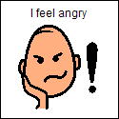

3. When I feel angry, there are things that I can do and things that I cannot do!

I cannot hit, kick, or hurt myself or others in any way!

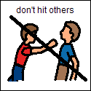 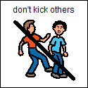 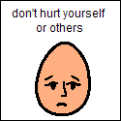

If I remember to use my strategies instead of being mean when I feel angry, I can start to feel better and not so angry. **My teacher will tell me how proud she is of me**!