**[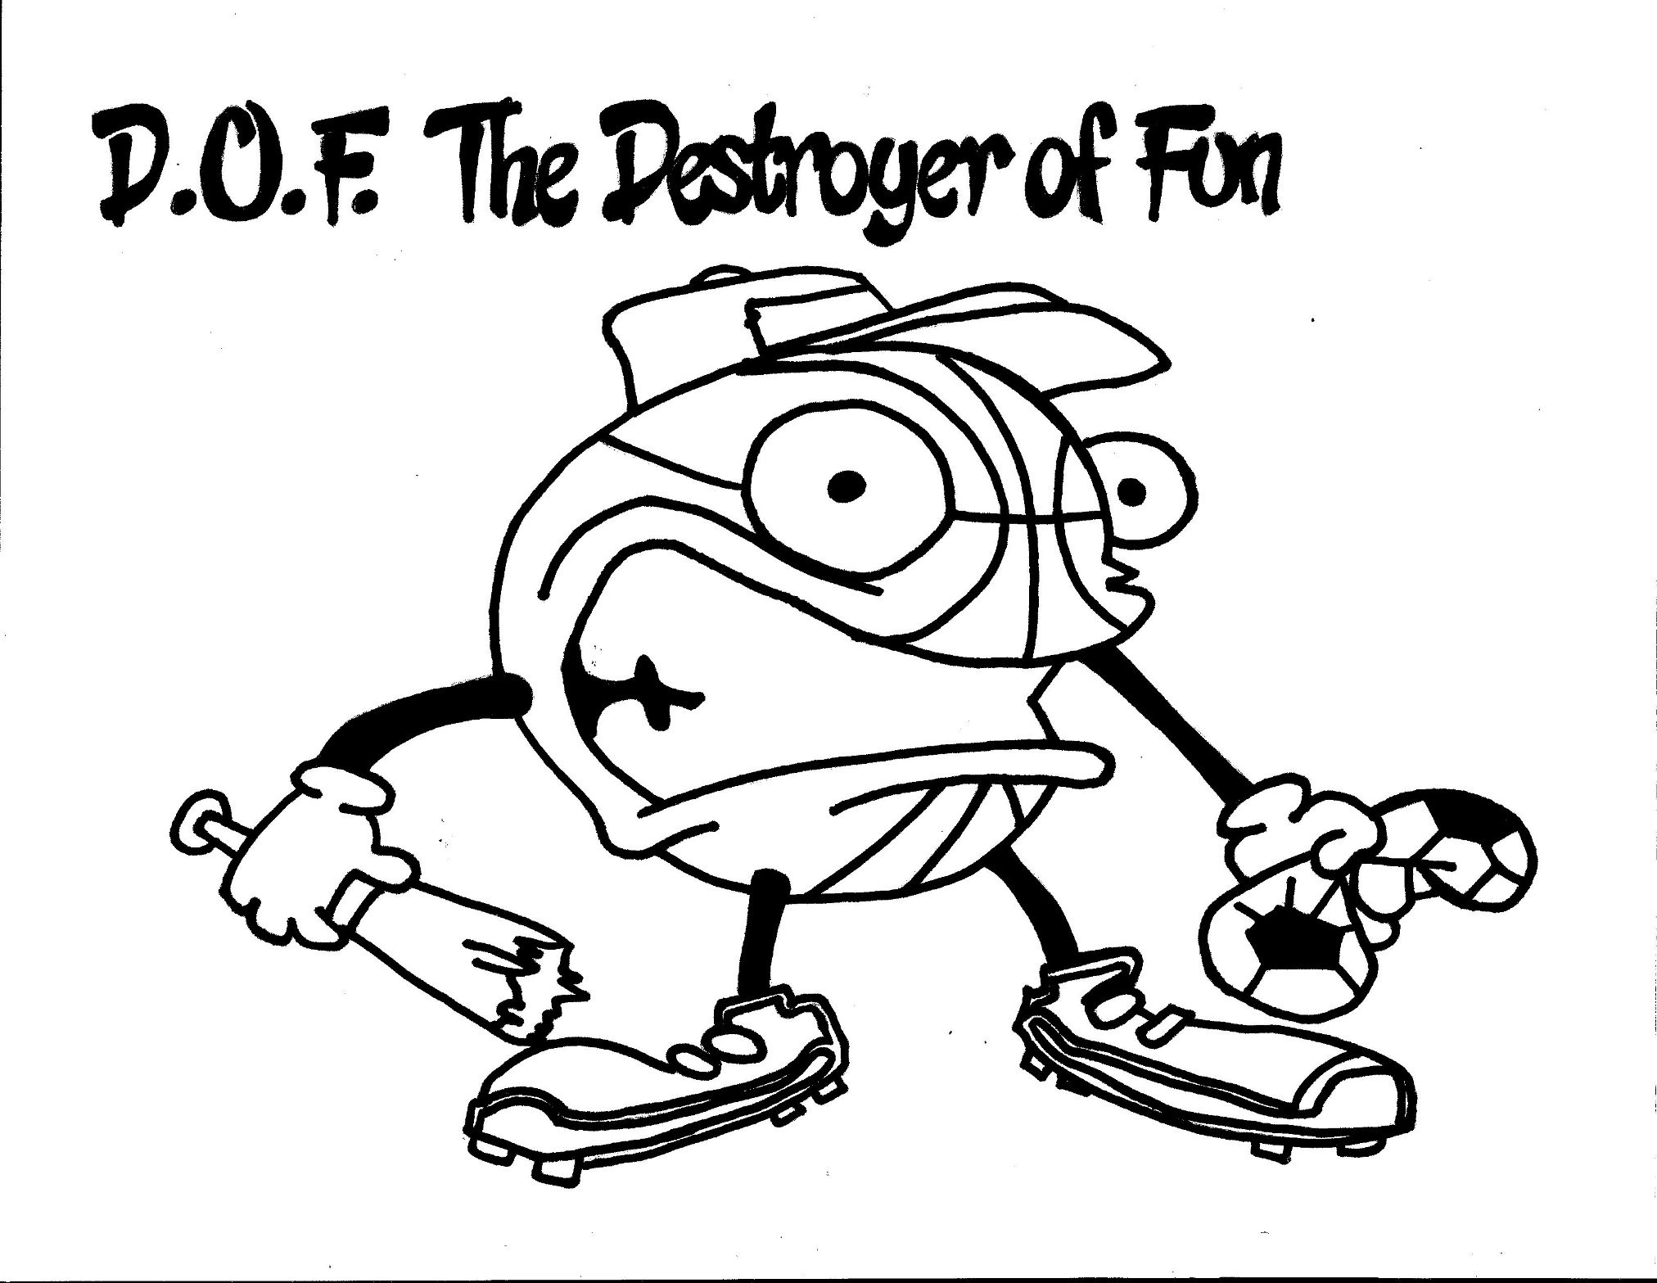](https://www.pinterest.com/appleteacher/destroyer-of-fun/)Powers:** D.O.F. makes you cheat,

change the rules, or be a bad winner or loser.

**Strategies:**

1) Use your eyes to see if everyone is having fun.

2) Self-talk “Losing is a small problem. I want to have fun!”

3) Self-talk “Am I just thinking about me?”