[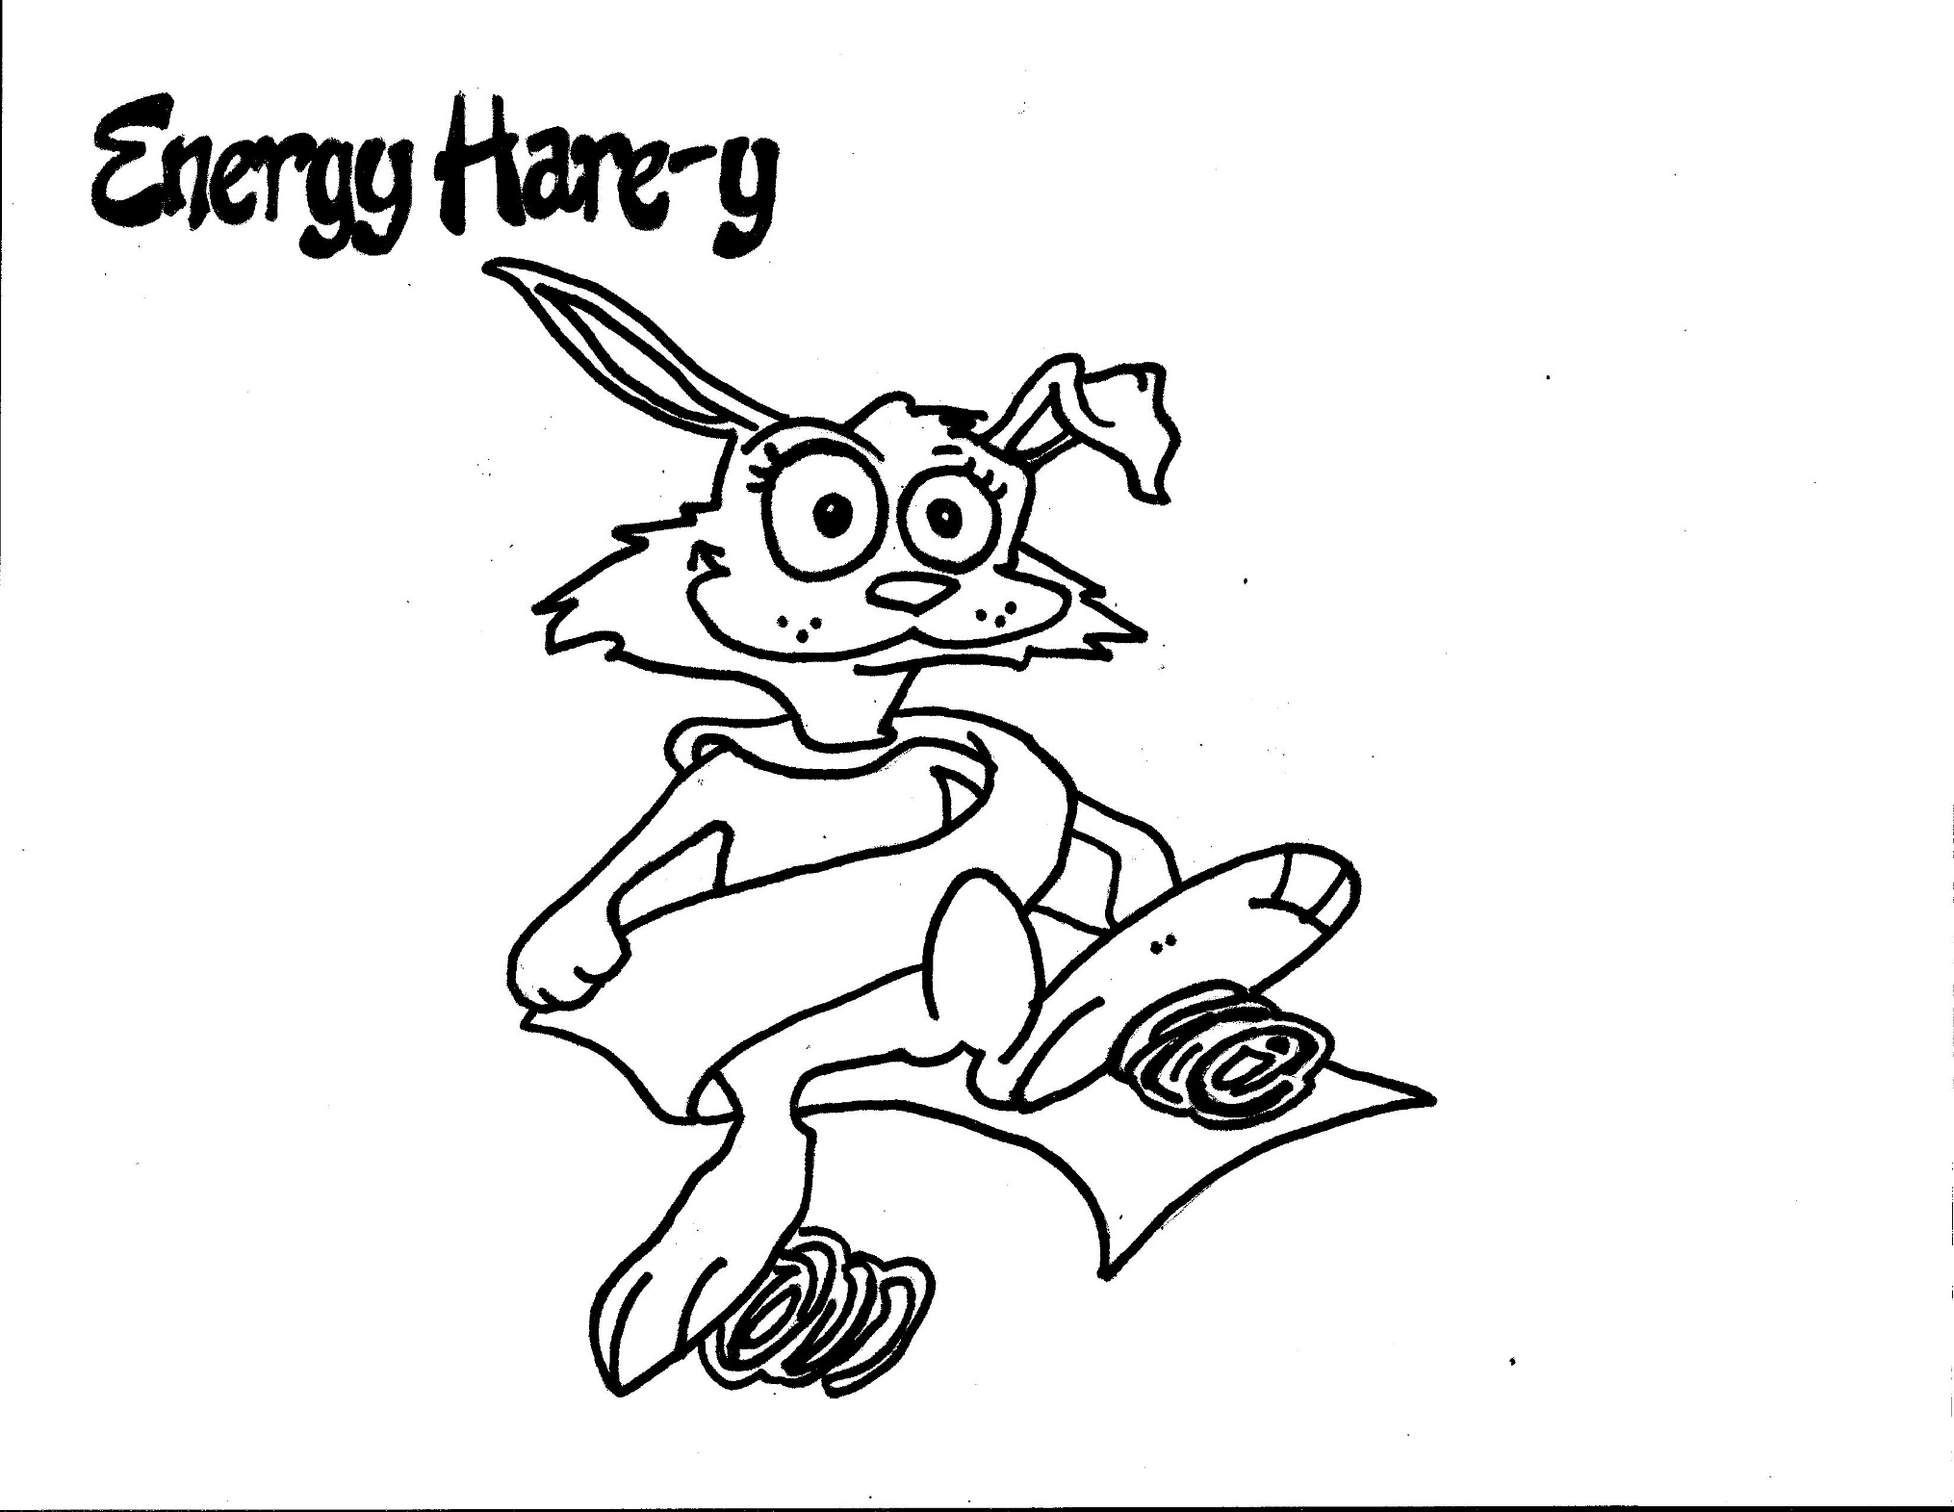](https://www.pinterest.com/andibruce/superflex/)

**Energy Hare-y makes me have too much energy!**

**When I have too much energy I can use my strategies:**

* 15 Jumping Jacks
* 15 Wall push-ups
* Use a fidget
* Take a walk