ZONES OF REGULATION

UNO

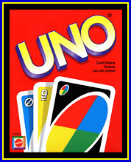

GAME RULES:

1. **Regular colored number cards**- Student has to give a feeling that is in the zone of the color card played
2. **Skip/Reverse Cards**- Student has to give an example of a time that they have felt in the zone of the color card played
3. **Wild Cards or Draw 4 Wild Cards**- Student has to act out an emotion of the color that they pick for WILD