**When I feel frustrated, I can:**

1. I can use my  strategies to help me!

2. My strategies are to ask for a break, walk away, or use a fidget to help me calm my feelings.



[](http://ontheworldmap.com/australia/) 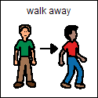

2. I can use words to tell teachers or kids that I feel angry or frustrated. Tell them “I need a break.” OR “I am frustrated because ________.”

[](http://clipart-library.com/speech-bubble-png.html)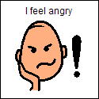

I feel frustrated

3. When I feel angry or frustrated, there are things that I can do and things that I cannot do! I cannot hit, kick, or hurt others in any way or run away!

[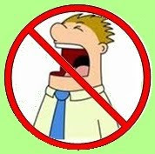](http://detsky-nabytek.info/2017/no-yelling-clip-art.asp)  [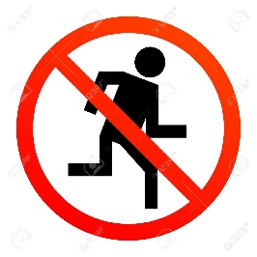](https://www.123rf.com/photo_13796237_no-run-sign.html)

If I remember to use my words instead of my body when I feel frustrated, I can start to feel better and not so upset. **My teacher will tell me how proud she is of me**!